Colorado Springs, CO Chapter #151
5 June 2022

Commander’s Corner:
Greetings, Companions! Memorial Day has just passed and provided an opportunity for us to honor those who made the ultimate sacrifice to secure the blessings of liberty and freedom for our country. While we did not have an official MOWW role in any local events, some of our members were able to attend events. I was out of the net due to COVID, so was not able to participate in any ceremonies, unfortunately.
Significant activities in May:
This month’s highlight was the May 14th Membership meeting. Judge David Shakes provided information regarding the Veteran’s Trauma Court. Judge Shakes is a retired Army Colonel and a Colorado District Judge. He is a strong advocate for veterans and presides over the 4th Judicial District Veterans Trauma Court. Ours was the first specialty court for veterans in Colorado and one of the first in the nation. The Veterans Trauma Court (VTC) is a state and grant funded problem-solving court that provides an alternative to incarceration for U.S. military veterans and active-duty military personnel with trauma spectrum disorders and/or substance abuse issues who have proven to be high risk and high need. Judge Shakes explained how servicemembers returning from war, particularly from multiple deployments, have invisible injuries as well as physical injuries. A small percentage have issues resulting in a number of issues, including drunk driving, weapons charges, disorderly conduct, and assaults that end up in the criminal justice system. The Trauma Court is for those who plead guilty, and a deferred sentence is granted until successful completion of the program. It is a problem-solving court that involves a team that combines therapy and treatment as well as legal and police officers. A mentor is assigned to help the servicemember in transition, including helping them find a job.

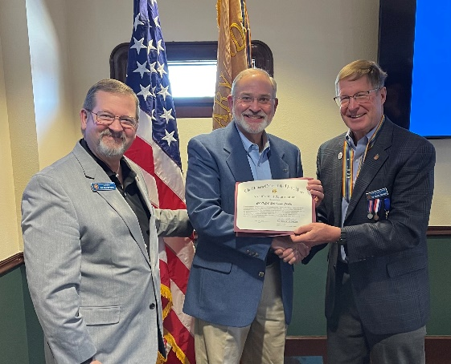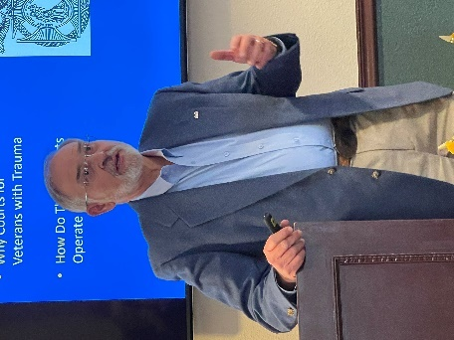
Col Reed & Col Shambach present Judge Shakes speaking
MOWW Certificate to Judge Shakes
One of our members, Col (USA, ret.) Lee Van Arsdale was honored at West Point as a Distinguished Graduate. I was able to attend his ceremony since we are Classmates. Proud to see one of our members honored.

Our Chapter added seven new members this year! We are pleased to welcome Dr. (Lt Col, USA, ret) Phil Mallory and Mr. Jonathan Cole as new companions, inducted at the May Membership Meeting. Thanks to Companions Kerm Neal, Bob Bythewood and Paul Willey who joined me in recruiting these new members! We will induct them at our July MOWW Membership meeting. We received a dividend of almost $2000.00 based on the number of perpetual members in our order. Your recruiting efforts not only strengthen the Chapter, but also assist increasing our resources! In addition, our Operating Year ends June 30th and we have submitted our Chapter for several awards to be recognized at the MOWW Annual Convention in August.

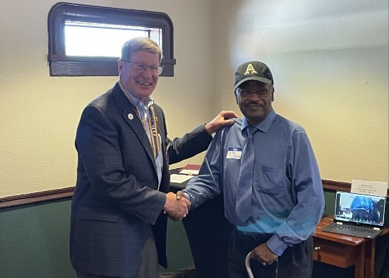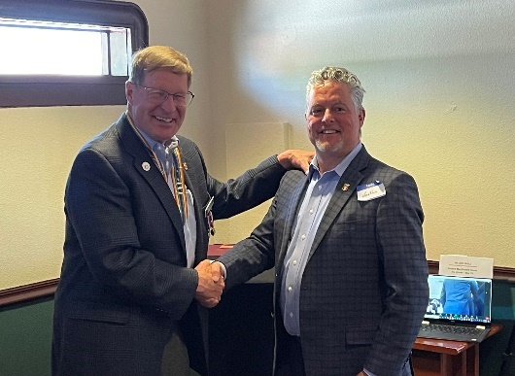
Lt Col Phil Mallory inducted Jonathan Cole inducted
by Col Shambach by Col Shambach

Finally, I had the honor of presenting the Lufbery Award to Cadet First Class (now 2LT) Felix Zheng at the Air Force Academy Awards Ceremony in the Department of Foreign Languages. The MOWW Outstanding Cadet in Western Language Minor Award (United States Air Force Academy) is a National level Award. This award in in memory of Major Gervais Raoul Victor Lufbery (March 14, 1885 – May 19, 1918) was a French and American fighter pilot and flying ace in World War I. Because he served in both the French Air Force, and later the United States Army Air Service in World War I, he is sometimes listed alternately as a French ace or as an American ace. Officially, all but one of his 17 combat victories came while flying in French units. This award is presented annually to the United States Air Force Academy (USAFA) cadet who, above all other cadets, excels in western languages. The USAFA faculty determines the recipient on behalf of the Order.
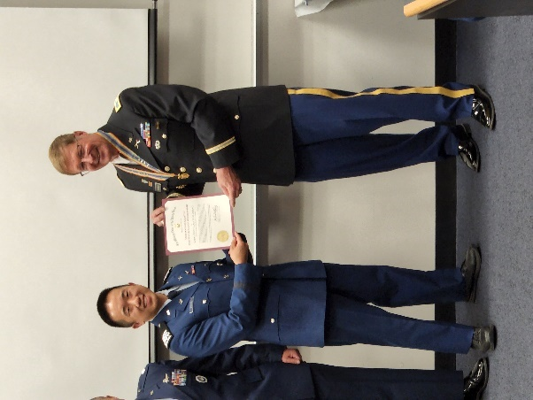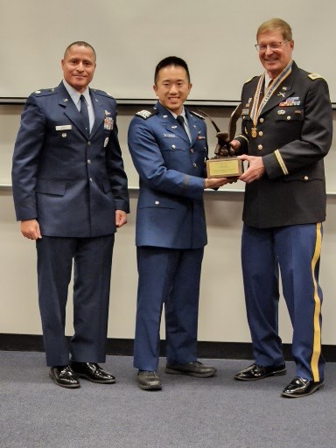
Col Shambach presents Lt Col Javier Reyes, USAFA
MOWW Certificate to and Col Shambach presenting
C1C Felix Zheng an engraved trophy to C1C Zheng

Looking ahead, we are ramping up for our annual Rocky Mountain Youth Leadership Conference. This is part of the MOWW Patriotic Education Program enabling about 100 high schoolers entering their senior year to develop as good, informed citizen leaders. This year the conference will be held 20-24 June at UCCS. If you are interested in visiting the conference, you may register at: 2022 RMYL Conference Visitors - Rocky Mountain Youth Leadership Foundation, Inc. (flipcause.com) . Note that due to the conference, there will not be an MOWW Membership Meeting in June.
- Administrative

Member Birthdays: Best wishes for the following companions:
June: Maj Dean Rizzo – 5 Jun; Maj John Helinski – 8 Jun; Mr. Walter Roy – 8 Jun; Lt Col Richard Peters – 12 Jun; LTC James Liedle – 15 Jun; Maj William Frier – 16 Jun; CPT Daniel Monroe – 16 Jun; LTC Chad Henderson – 20 Jun; COL Mark Weinerth – 23 Jun; Lt Col Ulysses Swift – 28 Jun; Lt Col Jo Carroll – 30 Jun
July: Ms. Eunice Hill - 9 Jul; Maj Donald Johnson – 9 Jul; Lt Col Edward Tomlinson – 11 Jul; COL Barrie Town – 11 Jul; Col Frank Seaman – 12 Jul; Mrs. Sandra Russell, PHD – 16 Jul; MAJ William Hybl – 16 Jul; Lt Col Douglas Brower – 21 Jul; Lt Col Jon Wisham – 30 Jul
- Staff Reports
  - Monthly Staff Report. Staff Meeting held on May 12th. The following are items of interest:
  - Treasurer’s Report. Mike Berendt. (May)
CDs: | $12,205.98
Checking: | $6,371.41 |  | Expenses: Patty Jewett Luncheon; plaques & engraving; Income from Dividend
Savings: | $101.12
Total: | $18,678.51

We received the annual Membership Dividend of $1966.03 from National MOWW based on our Perpetual Member strength!

Adjutant Membership Report-Ulysses Swift
Current number of members | 80 | Change since last month
Residing in Colorado | 69
Members over age 75 | 26
Members below age 75 | 54

4. Committee Reports

a. ROTC/JROTC- We need someone to take over this program. Contact Mike Berendt if you are interested in helping. - Mike Berendt, Ulysses Swift, Brian Gauck, John Russell and Jim Taylor presented JROTC awards and Rich Peters presented ROTC awards to the UCCS Army ROTC chapter. Mike has developed an SOP to help future program manager.

b. Patriotic Education-Rocky Mountain Youth Leadership Conference involving 100 high school seniors, 20-24 June 2022 at UCCS. Final preparations underway to conduct this conference.

c. First Responders-Dr. George Reed. The Fireman’s Awards Banquet is scheduled for June 10th, and our chapter will sponsor a table.

d. Programs-Steve Shambach

(1) June-No General Membership meeting. RMYLC conducted 20-24 June at UCCS

(2) July 28th, Thursday evening (T) LCdr (USN, ret) Coy Ritchie, Commander Denver MOWW Chapter, regarding his Navy experiences. He will also preside over the installation of Chapter officers.
f. Scouts: Kerm Neal and Steve Shambach headed up the presentation of several MOWW Certificates to Eagle Scouts at the Annual Region Banquet on May 24th. This provided the opportunity to promote and publicize MOWW and invite new members to join our Chapter. Photos of the ceremonies are posted on our website.

5. Old Business

Recruiting New Members! We will need your help to recruit new members for the new Operating Year, which starts 1 July. I am asking each member to identify at least one person to recruit this year!

(1) Volunteer Solicitation. We are soliciting from membership volunteers for the following vacant positions (please go to MOWW website for job descriptions if you are interested in these positions). These are non-elected positions.

Historian (Priority Position Steve would like filled)

Public Relations (Priority Position Steve would like filled)

Marshall

Chaplain

Judge Advocate

b. National Convention. The next MOWW National Convention is in Pensacola, FL 4-8 August. Information is provided in the current issue of Officer Review. This is a very worthwhile gathering of MOWW members nationwide, including Puerto Rico. I encourage you to consider attending to learn more about MOWW and meet other Commanders, staffs and members. You can register at the MOWW Website www.moww.org

6. New Business.

Rich Peters procured a new Laptop computer. This Chapter computer will be used for all Chapter business. The Chapter Commander will be the primary custodian of the computer.
- Functional areas prepare submissions for National Recognition due by 1 June as of 30 June for

7. Next Staff Meeting: Thursday, 16 June, 1700 at Hill House.

8. Next Chapter Meeting: Thursday, July 28th 2022

When: Social time at 1700 (cash bar); Call to Order at 1730; Dinner at 1745; Adjourn at 1930
Where: Patty Jewett Golf Course, 900 East Espanola, Colorado Springs, CO 80907
Speaker: Biography of LCDR Coy D. Ritchie, USN (Ret),General Manager and Owner of Ritchie Management Services
Seaman Recruit Ritchie enlisted in the United States Navy in 1956 and attained the rank of Chief Petty Officer prior to being commissioned in 1966. His sea assignments included tours in the USS Carpenter (DD 825), USS Morton (DD 948), USS Mahan (DLG 11), USS Frontier (AD-25), and USS Wainwright (CG 28). His shore assignments included tours as Director of the Fire Control Technician Class A School, Director of the Navy Electronics School, and as an Exchange Officer in the Greek Navy. After 22 years’ service, he retired as a LCDR in 1978.

In his civilian career, Dr. Ritchie was employed by the Educational Services subsidiary of International Telephone and Telegraph (ITT) for 18 years. After retiring from ITT in 1996, he was appointed Vice President and Dean of Management at Colorado Technical University in Colorado Springs, CO. He served in several executive positions with the University over the next few years and retired as Chancellor in 2003. Upon leaving the University, Dr. Ritchie started Ritchie Management Services, a firm that provides property management services in the metropolitan Denver area. He continues with that endeavor as General Manager and Owner.

Dr. Ritchie is very active with volunteer organizations in the Denver area. For five years (2004-2009) he served as Training Officer and leadership instructor for the U.S. Naval Sea Cadet Corps, Lexington Division, drilling at the Navy Operational Support Center at Buckley AFB.

While serving in the Navy, Dr. Ritchie earned a Bachelor of Science Degree in Business Administration from Roosevelt University, Chicago, IL. As a civilian, he earned a Master of Business Administration from City University, Seattle, WA; and a Doctorate in Systems Management from Colorado Technical University, Colorado Springs, CO.

Coy Ritchie and Juanita (Pat) Domingo were married in Hawaii in 1959 and have two sons and one granddaughter living in Colorado.

Reservations Required: Please RSVP no later than Monday, 25 July to LTC Mike Berendt, berendt478@aol.com; (410)908 6777 and CC: Steve Shambach, shambachsm@msn.com; (719)447-5505

Cost: $25.00 per person, cash or check only please

Attire: Casual for men; comparable for women. Wear your MOWW nametag and paraphernalia!

Questions? CONTACT: Steve Shambach 719-447-5505 shambachsm@msn.com

For the Good of the Order.

Steve Shambach, COL, USA (Ret)
Colorado Springs Chapter Commander
H: 719.481.4776; C:719.447.5505
shambachsm@msn.com
“It is nobler to serve than to be served”
Attachment: Contribution/Pledge Form
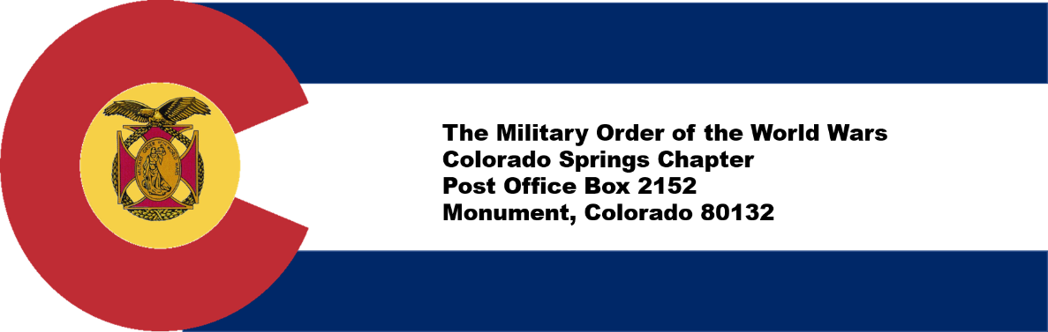

CONTRIBUTION OR PLEDGE
Yes, I am making a tax-deductible contribution or pledge to the Colorado Springs Chapter of the Military Order of the World Wars.

I wish to contribute or pledge $__________to the Patriotic Education Fund.

I wish to contribute or pledge $__________to the ROTC Fund.

I wish to contribute or pledge $__________to the Boy and Girl Scout Fund.

I wish to contribute or pledge $__________to the Law & Order Fund.

I wish to contribute or pledge $__________to the Operations Fund (postage, bulletin, directory, recognition programs – plaques, medals, etc.)

___________________________________________________________________
Name
Please make checks payable to Colorado Springs Chapter, MOWW
Send to: LTC Mike Berendt
1230 Bowstring Road
Monument, CO 80132

