Colorado Springs, CO Chapter #151
4 October 2021

Commander’s Comments:
Greetings, Companions!
Fall is here, as the temperature and Aspen trees reveal. I hope you had a chance to view the beautiful autumn colors!
Our chapter has been very busy for September.
- We combined our membership meeting with the Rocky Mountain Youth Leadership Foundation (RMYLF) fund raiser for the 2022 Youth Leadership Conference (YLC), scheduled for 20-24 June at University of Colorado, Colorado Springs (UCCS). This event kicks off our fund-raising efforts for next year’s conference. The fund raiser was held at Patty Jewett Golf Course on September 22nd. We had over fifty attendees and raised around $10,000.00! Thank you for all who attended and contributed. A special thanks to Anja Wynne and RF Smith who did the lion’s share of the work planning and executing the fund raiser. The evening’s highlight were the testimonials from parents and students who attended last year’s conference. The students provided compelling and sincere testimonials regarding the value and impact of the conference on their development as future leaders. The parent testimonials emphasized their appreciation of YLC emphasizing the importance of patriotism throughout the conference, a subject that is neglected in school curriculum and in public discourse. We also showed a video of the Cyber Security “awesome power” skit that won the YLC student group presentation. That provided the audience with a visual portrayal more powerful than a narrative about the exercise.
- On September 24, our MOWW Chapter sponsored a 10-person table at the Police Foundation of Colorado Springs annual Medal of Valor dinner at the Broadmoor. We joined other private citizens, community organizations and businesses to recognize the Colorado Springs Police Department first responders to express our support for their mission to make Colorado Springs a better, safer place to live and honor police officers for their heroic and sacrificial actions to protect our community. The Chapter raised enough funds to allow several MOWW members and spouses to attend with three YLC students plus police officers and spouse to attend this function (see picture on following page). This was an opportunity for our Chapter to demonstrate support for First Responders which is one of the cornerstones of the MOWW mission.
- . 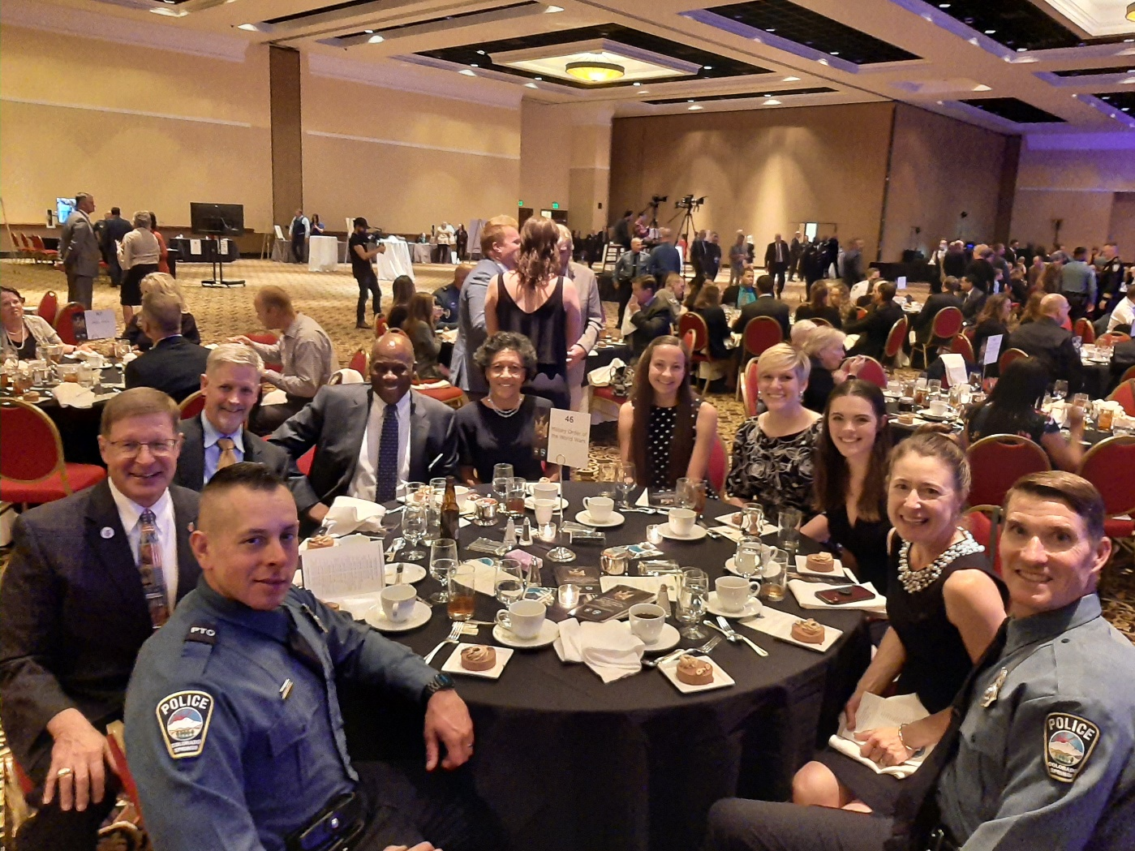
From Front Left and clockwise: Officer Gerard Bowmans, Col Shambach (Cdr), Col Neal (Jr. Vice), Lt Col & Mrs. Ulysses Swift (Adjutant); Abigail Deyoe, Griffin Greenwood, Olivia Ward (YLC counselors/students); Mrs. Jennifer Marino-Parsons and husband Officer Bill Parsons

Member Birthdays: Best wishes for the following companions:
October:
Col John Abbatiello – 5 Oct | COL Lee Van Arsdale – 6 Oct
LT Robert Bythewood – 20 Oct | Col Watt Hill – 23 Oct
LTC Victor Tise – 26 Oct | Capt Ronald Maw – 30 Oct
November:
COL Michael Boatner – 1 Nov LTC John Russell – 5 Nov
MAJ Roosevelt Hines, Jr. – 17 Nov Col Richard Rima – 21 Nov

Monthly Chapter Report
We did not hold a Staff Meeting in September. The following are items of interest carried over from the August meeting:

1. Treasurer’s Report-Jim Taylor. (September)
CDs: | $11,880.88 |  | Expenses
Checking: | $101.09 |  | Paid for Website, Hub and Spoke, $45.00
Savings: | $6312.60
Total: | $18,294.57

2. Committee Reports

a. ROTC/JROTC- No Status To Report (NSTR)

b. Patriotic Education-Steve. RMYLC 2021 completed. Should get money for each student who attended. Check will come to Steve.

c. Membership-Ulysses Swift.
Current number of members | 77
Residing in Colorado | 67
Members over age 75 | 24
Members under age 75 | 43

d. Programs-Steve Shambach

(1) Boy and Girl Scouts-Kerm Neal/Jim Taylor. Kerm will send out a note to re-energize the Eagle Award recognition by MOWW.

(2) Homeland Security/National Defense- Jon Wisham. Steve will meet with Rudy Veit to see if he is willing to join MOWW and help with this program.

e. First Responders. George Reed. See Medal of Valor Dinner write up.

f. Rocky Mountain Youth Leadership Foundation (RMYLF) and RMYLC-Steve. See Fund Raiser.

3. New Business

4. Old Business.

a. Due Outs

(1) All Recruit new members!

(2) Chapter needs to complete required documents for state tax exempt status using MOWW Federal 501(c)19 Veteran Tax Exempt status. Rich Peters and Mike Berendt working on this initiative. National HQs is exploring Tax Exempt 501(c)3 status for entire organization.

(3) Steve Programs:

(a) October: Dinner meeting on 22 October. Details below

(b) November: Scout update. Kerm lined up speakers for the November meeting. Save the Date: Saturday, 13 November, 1100-1330, Scout Update, Patty Jewett Golf Course.

(4) Hill House poster is now displayed in the window of the Hill House in Palmer Lake, at 130 Upper Glenway, Palmer Lake, CO designating the Chapter Headquarters. Please come by and take a look at the building in picturesque Palmer Lake.

b. Soliciting from membership volunteers for the following vacant Positions (please go to MOWW website for job descriptions if you are interested in these positions):

(1) Historian (Priority Position Steve would like filled)

(2) Public Relations (Priority Position Steve would like filled)

(3) Marshall

(4) Chaplain

(5) Judge Advocate

c. We need to work up a Staff succession plan for the next 3 years; By bylaws, this is last year for Commander and several others are on extension.

d. We can submit articles to Officer Review MOWW Magazine. It suggested that we establish a Scribe Position.

e. Chapter Action Plan completed.

f. Marketing and Outreach. Steve is on a National MOWW Strategic Initiatives committee. They are contracting a marketing organization to help MOWW improve their marketing.

5. Next Staff Meeting: Thursday, 21 October 1700, at Hill House

6. Next Chapter Meeting: Tuesday, 26 October 2021
When: Social time at 1700 (cash bar); Call to Order at 1730; Dinner at 1745; Adjourn at 1930
Where: Patty Jewett Golf Course, 900 East Espanola, Colorado Springs, CO 80907
Speaker: Colorado Springs Fire Chief, Randy Royal. He will be speaking about the current state of the fire department, challenges and opportunities as a first responder.
Reservations Required: Please RSVP no later than 15 October 2021 to LTC Mike Berendt, berendt478@aol.com; (410)908 6777
Dinner Menu: TBD
Cost: $25.00 per person, cash or check only please
Attire: Casual for men; comparable for women. Wear your MOWW nametag and paraphernalia!
Speaker Bio: Fire Chief - Randy Royal
Chief Royal has been a member of the Colorado Springs Fire Department since 1987 and has worked in emergency services for over 42 years (28 years as a paramedic). Chief Royal has served in a Chief Officer role for 16 years, as a Battalion Chief, Shift Commander and Deputy Chief. He graduated from Flagler College and has regularly attended the National Fire Academy receiving the Executive Fire Officer designation. He also has earned the Center of Public Safety Excellence’s designation as a Chief Fire Officer. Chief Royal has presented numerous classes in the state and region to include the Colorado State Chiefs Conference, Fire-Rescue International, and Missouri Valley Chiefs Conference.
During his career, he has been involved in many programs and projects to include the initiation of the Tactical Emergency Medical Program, worked in the early Hazmat and Tox-medic Programs, managed the Medical Division, helped develop the Awards and Recognition Program, chaired the department’s Rebranding Committee, and presently leads the Pandemic Taskforce. He has been recognized over his career with numerous awards to include two Medals of Distinguished Service and the Firefighter of the Year award. He is proudest for being recognized as part of the department’s efforts with the Castle West Apartment fire, Waldo Canyon fire, and the Black
Questions? CONTACT: Stephen Shambach 719-447-5505 shambachsm@msn.com
For the Good of the Order.

Steve Shambach, COL, USA (Ret)
Colorado Springs Chapter Commander
H: 719.481.4776; C:719.447.5505
shambachsm@msn.com
It is nobler to serve than to be served
Attachment: Contribution/Pledge Form

CONTRIBUTION OR PLEDGE
Yes, I am making a tax-deductible contribution or pledge to the Colorado Springs Chapter of the Military Order of the World Wars.

I wish to contribute or pledge $__________to the Patriotic Education Fund.

I wish to contribute of pledge $__________to the ROTC Fund.

I wish to contribute of pledge $__________to the Boy and Girl Scout Fund.

I wish to contribute of pledge $__________to the Law & Order Fund.

I wish to contribute of pledge $__________to the Operations Fund (postage, bulletin, directory, recognition programs – plaques, medals, etc.)

______________________________
Name

Please make checks payable to Colorado Springs Chapter, MOWW
Send to: Col Jim Taylor
19675 W. Top O’ the Moor Drive
Monument, CO 80132-9327

