**COMMANDER’S CORNER (13 OCTOBER 2022)**

We will have a regular face-to-face General Membership Meeting on Saturday, 22 October 2022, starting at 11:30 A.M. The meeting will be held at Las Brisas Restaurant, 6787 S. Clinton Street, Greenwood Village, CO. The featured speaker will be Capt Dennis Orr, USAF (Fmr) who is also our newest member to be installed at the meeting.

To get there (Las Brisas Restaurant), if you are coming from east of I25, drive west on Arapahoe Road to South Clinton Street (about a block before you get to I25) and take a left turn. Do not turn on Clinton Court as the next street is South Clinton Street. The restaurant is located on the east side of the Target Store parking lot. If you are coming from west of I25, drive east on Arapahoe Road until you pass under I25. The first street on the right is South Clinton Street. Turn right and you will see the restaurant on the east side of the Target Store parking lot. If you get lost, you can call me at 303-981-5519 (cell) and I will try to get you un-lost.

For planning purposes, Region XIII will be having

our next Conference January 18-20, 2023 in the Phoenix area. I will let you know the actual site as soon as I am informed. Pat and I plan to attend.

Coy D. Ritchie, D.M.

LCDR, USN (Ret)

Denver Chapter Commander

***It is nobler to serve than to be served***



**STAFF MEETING (8 September 2022)**

This meeting was conducted at Frances Long’s Home and was called to order at 1105 hours by Denver Chapter Commander LCDR Coy Ritchie. Also attending were LT Evan Totten, HPM Pat Ritchie, HPM Frances Long and HPM Stephanie Ritchie. CPT Bob Mallin, M.D. attended by Zoom. The Invocation was offered by LT Totten followed by the Pledge of Allegiance led by LCDR Ritchie.

Minutes The minutes of the meeting on 8 September 2022 were approved on a motion by LT Totten and seconded by HPM Stephanie Ritchie.

Financials The Treasurer’s Report as of 30 September 2022 was submitted by LCDR Ritchie. The month ended with a U.S. Bank fund balance of $6,972.37 and ENT Credit Union fund balance of $8,872.63. The Treasurer’s Report was approved on a motion by CPT Mallin and seconded by LT Totten. A motion to renew the Zoom account was made by LT Totten and seconded by HPM Stephanie Ritchie. Motion was approved unanimously.

Scouts LT Totten reported that communications have begun with the Greater Colorado Council to obtain the names of the Eagle Scout nominees.

ROTC, JROTC Nothing new to report.

Patriotic Education LCDR Ritchie reported that the RMYLF conducted a fund raiser at the Flying W Ranch in Colorado Springs on 27 September. There were 190 attendees and approximately $25,000 was raised. It now costs approximately $600 per student completing the one week long Youth Leadership Conference.

Public Safety and Law and Order Nothing new to report.

Region XIII and Dept. of the Rocky Mountains LCDR Ritchie reported that there will be 4 Region XIII Conferences held in 2022/2023. They will be: 1st Qtr. Zoom Conference on 10/7/22 at 7:00 PM MDT, Fall Hybrid Conference on January 18-20 in Phoenix area, 3rd Qtr. Zoom Conference on 4/14/23 at 7:00 PM MDT, and Spring Hybrid Conference on June 15-16 in the Tucson area.

Membership/Recruiting LCDR Ritchie reported that the Chapter has a new member, Capt Dennis Orr, USAF (Fmr) who will be installed at the General Membership Meeting on 22 October 2022.

Hospitality The next General Membership Meeting will be held on Saturday, 22 October 2022 at Las Brisas Restaurant. Please bring your spouse and friends for a delicious Mexican or Spanish lunch. We will order off of the menu.

Program/Speaker The speaker will be Capt Dennis Orr, USAF (Fmr).

Old Business LCDR Ritchie presented a reminder of the dinner meeting with the Colorado Springs Chapter on 27 October 2022.

New Business LCDR Ritchie submitted the preliminary proposal for the 2023 Chapter Budget.

Next Staff Meeting The next staff meeting will be held on Thursday, 10 November 2022 starting at 1100 hours at the home of Frances Long. It is planned to have backup by Zoom for those unable to attend in person.

Benediction Offered by LT Totten.

Adjournment LCDR Ritchie adjourned the meeting at 1205 hours.



**COMING EVENTS (October & Later)**

* **STAFF MEETING (10 November 2022)**
  + (Thursday), 11:00 A.M.
  + Location: Frances Long Home

* **MOWW NATIONAL CONVENTION**

**(August 2023)**

* + Location: Annapolis, MD
* **MEMBERSHIP LUNCHEON**

**(22 October 2022)**

* + (Saturday), time 11:30 A.M.
  + Location: Las Brisas Restaurant, 6787 S. Clinton Street, Greenwood Village, CO.
  + Menu: Order from the menu and each individual will pay their own bill.
  + Program: Capt Dennis Orr, USAF (Former)



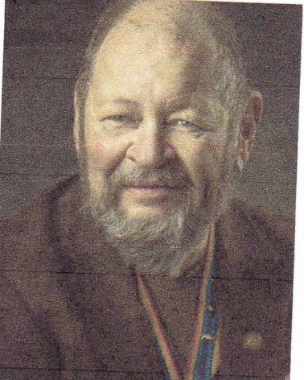

**Bob**

**PREPARE YOUR BODY FOR WINTER**

CPT Robert E. Mallin, MD, USA (Fmr)

Surgeon General, MOWW

Those who snowboard, play hockey, skate, etc., know they need to “get ready” and prepare themselves for participation in these sports. We may be far ahead of the winter season, but as we age an early start to conditioning gets more important each year. Suck exercises will serve you well if done early and before each sports outing.

From simply crouching at the knees with a relatively straight back and bending on one or both legs to the staggered grip pull-ups of ice climbing, most sports demand a conditioning period. A routine that is exhausting but works is to do a routine of 100 squats, 100 pull-ups, 100 sit-ups and 100 pushups. This will have to be snuck up on for a while but will set you up eventually and well for any sport.

In the winter, you especially need flexibility and rotation, toe to heel balance, knee flexing, and extension of all lower extremity joints for snow sports. You can achieve these using an agility ladder while holding a medicine ball. I also recommend using “step-up” devices for conditioning vs. actually using a set of stairs. This will balance the strength of your generally stronger quadriceps on the front of y0ur legs, and the hamstrings on the back of them.

Another approach involves using plyometrics. Plyometrics, i.e., “jump training” or “plyos,” are exercises based around having muscles exert maximum force in as short a time as possible, with the goal of increasing both speed and power. This training focuses on learning to move from a muscle extension to a contraction in a rapid or “explosive” way, e.g., specialized repeated jumping Plyometrics, in combination with squatting and cycling, provide many benefits. The technique is to jump off a one-foot high height and immediately jump back 10-30 seconds at a time, alternating legs. Experts do this on just one leg. Be sure to get some good guidance before doing this to avoid injuries, **preferably from a sports fitness expert**.

A good stretching modality, also important, is the core twist, i.e., turning at the waist. It is an easy maneuver. To develop endurance, bike on a road, a mountain, or on a stationary bike at home. This increases your heart and lung capacity while strengthening the legs. The regime: 30 seconds of maximum effort, rest, and repeat two to five times per session. Stepping to the side from a squat position and eventually jumping from side to side improves agility. Your knee’s anterior cruciate ligaments (ACLs) are susceptible to injury in all of the above, so be careful.

These are a few of the basic ways to prepare your body for all sports. Although all sports have requirements for excellence, I recommend participating in sports for personal enjoyment. Most important, be sure you are otherwise physically able to do the activity. Your health provider and a sports medicine pro can be of great value—use them! Again, it is impossible to over emphasize the absolute importance of your doc’s “medical clearance” and the guidance of the top of the line professional. Remember “we ain’t 24 no more.”/be well/ Bob

*MOWW OFFICER REVIEW * June 2014 p22 The Military Order of the World Wars*

*CPT (Dr.) Robert E. Mallin, USA (Former) is a graduate of Adelphi University and New York Medical College. He is certified with the American Board of Plastic and Reconstructive Surgery and is a Fellow of the American College of Surgeons. In private practice from 1975-94, he was the Alaskan State Physician of the Year. While in the U.S. Army (1966-1968) he earned a Bronze Star, Purple Heart and Air Medal, and a Combat Medical Badge, among other decorations.*

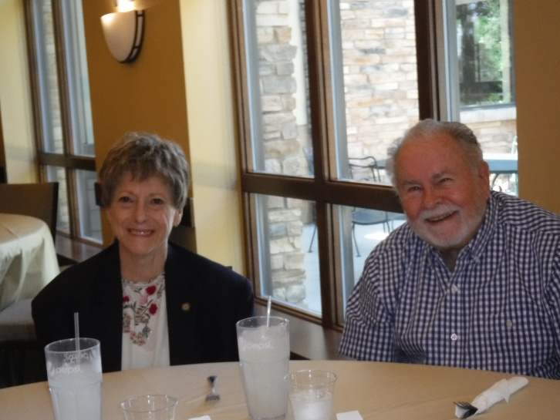

**Capt Dennis Orr, USAF (Fmr), our newest companion, and his spouse Judy, attending the MHMOA Luncheon at the Rendezvous Restaurant on 9/9/2022. Welcome aboard Dennis and Judy!**

**POINTS OF CONTACT**

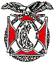**Denver Chapter (093), CO**

**Commander and Treasurer**

LCDR Coy Ritchie, USN (Ret)

4198 South Kirk Court

Aurora, CO 80013-6022

303-690-5118 (Res), 303-981-5519 (Cell)

[**coyritchie@aol.com**](mailto:coyritchie@aol.com)

**Adjutant**

HPM Frances Long

6278 S. Kearney Street

Centennial, CO 80111-4237

303-694-1079 (Res)

[grannyfrancene@netzero.net](mailto:grannyfrancene@netzero.net)

**Commander, Rocky Mountains Department**

COL Steven A. Shambach, USA (Ret)

[shambachsm@msn.com](mailto:shambachsm@msn.com)

**Commander, Region XIII**

LTC Patrick C. Stolze, USA (Ret)

[pstolze40@gmail.com](mailto:pstolze40@gmail.com)