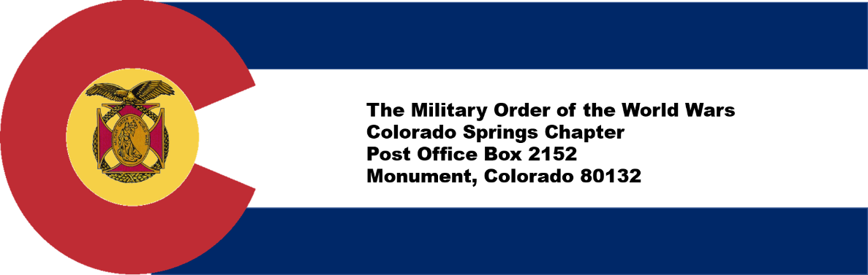

Colorado Springs, CO Chapter #151
6 October 2022

Commander’s Corner:
October has arrived and our MOWW Chapter is in full swing as we begin fall weather. On 23 September, our Chapter supported the Medal of Valor Banquet for the Colorado Springs Police Department; MOWW donated funds to reserve a table and filled six seats with four police officers as our guests. Companion George Reed was the overall Banquet chairman.

On September 27th, in lieu of our monthly membership meeting, we supported the Rocky Mountain Youth Leadership Foundation fund raiser at the Flying W Ranch. If you have not been to Flying W Ranch since it was restored from the Waldo Canyon fire, you should definitely check it out. Companions Anja Wynn, RF Smith and Jonathan Cole did yeoman’s work to make it a success. Thanks to all who participated or donated. Companions, please consider using the attached form to donate to the Patriotic Fund to support this worthwhile endeavor.

Looking ahead, we are planning a JROTC program on Thursday, 27th of October for our monthly meeting. The Staff is reviewing requirements for Veteran’s Day ceremonies to determine if we can support any activities. Please contact anyone on Staff if you want to volunteer for any
Veteran’s Day activities and review our November bulletin for activities the Staff would want the Chapter to support. We are tentatively planning to hold our final calendar year meeting on Saturday, 3rd of December. Please save that future date if you want to attend the last meeting of the year before we take a break for the holidays.

Our Chapter continues to grow, and we appreciate your efforts to bring new companions to our Order.
If you have any suggestions for how MOWW can better serve you and fulfill our mission, please let me or our Staff know.

We have commissioned a local vendor to produce MOWW Polo Shirts. We anticipate having these shirts available for viewing at the next Chapter meeting and will include pictures in our November bulletin. Companions can order shirts after the October 27th meeting.
Chapter Activities for September.
Colorado Springs 9/11 Commemoration Ceremony, September 11, Peace Officers Memorial in Memorial Park. Chapter 151 members, high school Navy JROTC cadets and Young Marines group supported the City of Colorado Springs Military Affairs Council in setup, escort duties, refreshments and breakdown for this event. The City of Colorado Springs hosted a 9/11 commemoration ceremony to honor victims of the September 11 attacks. The event featured remarks from Mayor John Suthers, Colorado Springs Police Chief Adrian Vasquez, Colorado Springs Fire Chief Randy Royal, and Colorado Springs Police Chaplain.

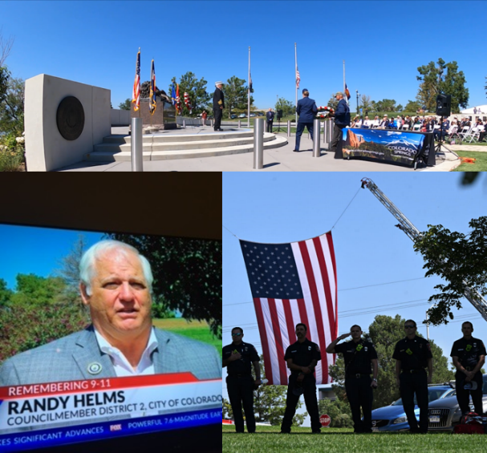
Companion and Colorado Springs City Councilmember Randy Helms was interviewed by local television stations and shared his story when he was at the Pentagon that day.

“What I remember is the uncommon valor that the American citizens displayed that day by rushing into danger, knowing what the consequences would be. That’s the history of our nation,” said Helms.

The event ended with a wreath-laying ceremony and a performance of Taps.

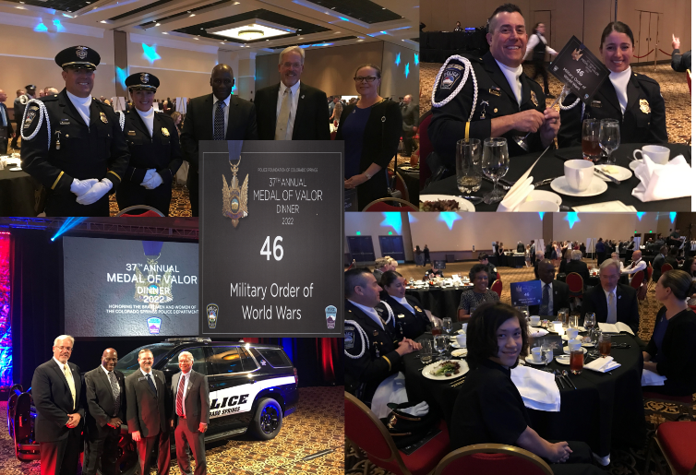
Colorado Springs Police Department 37th Annual Medal of Valor Dinner was held on September 23 at the Broadmoor Hall. As stated earlier, our MOWW Chapter sponsored a table. The Mayor, City Council members, local government representatives, citizens and businesses gathered to honor the valor and bravery of officers whose actions saved lives. Companions George Reed, Ulysses Swift, Richard Peters and Paul Willey accompanied by guests Colonel Molly Spedding, Beverly Swift, and Aidan Peters hosted two officers for this celebratory event. Companion George Reed had a prominent role as the Chairman of the Board of Directors/Officers of the Police Foundation that organized this event. Twenty-two officers were recognized with Medal of Valor or Distinguished Service Medals for risking their lives in officer involved shootings or putting their lives at risk saving citizens of Colorado Springs.
Rocky Mountain Youth Leadership Foundation Charity Fundraiser was held at the Flying W Ranch on September 29. The event was successful with 191 people attending and everyone seeking to achieve the foundations goal to raise enough funds to allow self-sustainment of the annual conference.

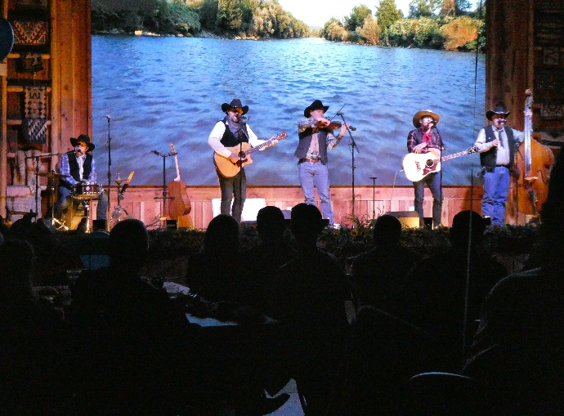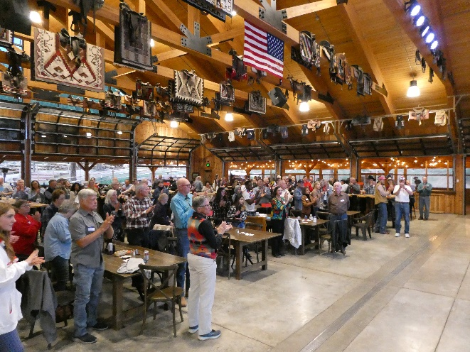

2. Administrative
Member Birthdays: Best wishes for the following companions:
October: Col John Abbatiello – 5 Oct; COL Lee Van Arsdale – 6 Oct; LT Robert Bythewood – 20 Oct
Col Watt Hill – 23 Oct; LTC Victor Tise – 26 Oct; Capt Ronald Maw – 30 Oct

November: COL Michael Boatner – 1 Nov; LTC John Russell – 5 Nov; MAJ Roosevelt Hines – 17 Nov
Col Richard Rima – 21 Nov

3. Staff Reports
  - Monthly Staff Report.
  - Treasurer’s Report.
CDs: | $12,297.88 |  | As of 6 Sept 2022
Checking: | $4,847.09 |  | Note: $675.00 expense for 30 Aug dinner has not cleared
Savings: | $101.13
Total: | $17,246.10

Adjutant Membership Report-
Current number of members | 82 | Change since last month
Residing in Colorado | 69
Members over age 75 | 23
Members below age 75 | 59
  - Any overdue dues: None
  - Applications received: None
4. Committee Reports
  - ROTC/JROTC- Col Joey Hinson, USAF (Ret), Senior Aerospace Science Instructor will present a JROTC presentation at 27 Oct MOWW meeting.
  - Patriotic Education- MOWW National Headquarters provided over $4500 for our conference last year. This is significantly more than we received last year and shows National MOWW commitment for Patriotic Education for our youth.
ii. RMYLF Fund raiser. 190 attendees and significant funds raised for future Conferences
iii. RMYLF Board Meets 6 October to approve the budget for 2022-2023
iv. The 2023 Rocky Mountain Youth Leadership Conference will be our 30th Anniversary Conference and will be held 12-16 June at CSU Pueblo. If you know any rising high school senior (current junior), encourage them to apply to attend through their guidance counselor or JROTC instructor. Also, if you would like to volunteer to plan and/or participate in the conference next year, let Steve Shambach know.
  - Programs- See Upcoming Events.
  - Boy and Girl Scouts - NSTR
  - First Responders - The Medal of Valor Banquet for the COS Police Department was held on 23 September 2022.
  - Homeland Security/National Defense- NSTR.

5. Recruiting New Members! We will need your help to recruit new members for the new Operating Year, which starts 1 July. I am asking each member to identify at least one person to recruit this year!

6. Volunteer Solicitation. We are soliciting from membership volunteers for the following vacant positions (please go to MOWW website for job descriptions if you are interested in these positions). These are non-elected positions.

Historian (Priority Position Steve would like filled)

Public Relations (Priority Position Steve would like filled)

Marshall

Chaplain

Judge Advocate

7. Next Staff Meeting: Thursday, 20 October 1730 Hill House. All are welcome to attend to check us out!

8. Next Chapter Meeting: October 27th, Thursday, 1700-1930, Patty Jewett Golf Course.

When: Social time at 1700 (cash bar); Call to Order at 1730; Dinner at 1745; Adjourn at 1930

Where: Patty Jewett Golf Course, 900 East Espanola, Colorado Springs, CO 80907

Speaker: JROTC Presentation. Speaker is Col Joey Hinson, USAF (Ret) Senior Aerospace Science responsible for the Mitchell High School JROTC Program. He has numerous years of experience as an AFJROTC instructor. We may have one or two AFJROTC Cadets who may accompany Col Hinson to our monthly meeting.

Reservations Required: Please RSVP no later than Monday, 24 October to LTC Mike Berendt, berendt478@aol.com; (410)908 6777 and CC: Kerm Neal (719) 205-1106. knealsfour@yahoo.com
Cost: $25.00 per person, cash or check only

Attire: Casual. Please wear your MOWW nametag and any MOWW awards.

9. Upcoming Events

October 27th, Thursday, 1700-1930, AFJROTC Presentation, Patty Jewett Golf Course

November Veteran’s Day Recognition, TBD

December 3rd (Tentative) Pearl Harbor Day Recognition TBD

For the Good of the Order.

Steve Shambach, COL, USA (Ret)
Colorado Springs Chapter Commander
H: 719.481.4776; C:719.447.5505
shambachsm@msn.com
“It is nobler to serve than to be served”
Attachment:
1. Contribution/Pledge Form

CONTRIBUTION OR PLEDGE
Yes, I am making a tax-deductible contribution or pledge to the Colorado Springs Chapter of the Military Order of the World Wars.

I wish to contribute or pledge $__________to the Patriotic Education Fund.

I wish to contribute or pledge $__________to the ROTC Fund.

I wish to contribute or pledge $__________to the Boy and Girl Scout Fund.

I wish to contribute or pledge $__________to the Law & Order Fund.

I wish to contribute or pledge $__________to the Operations Fund (postage, bulletin, directory, recognition programs – plaques, medals, etc.)

___________________________________________________________________
Name
Please make checks payable to Colorado Springs Chapter, MOWW
Send to: LTC Mike Berendt
1230 Bowstring Road
Monument, CO 80132

