**COMMANDER’S CORNER (9 SEPTEMBER 2021)**

Our summer break is ending and we had our first Staff Meeting of the 2021/2022 Operating Year today. Unfortunately, the issue of COVID 19 is still with us and appears to be on the rise again. However, as of today, we are still permitted to have sit-down inside meetings. Therefore we are planning to have a regular face-to-face General Membership Meeting on Saturday, 23 October 2021, starting at 11:30 A.M. The meeting will be held at Las Brisas Restaurant, 6787 S Clinton Street, Greenwood Village, CO. I am looking forward to meeting all of our Companions again after the summer vacation.

To get there (Las Brisas Restaurant), if you are coming from east of I25, drive west on Arapahoe Road to South Clinton Street (about a block before you get to I25) and take a left turn. Do not turn on Clinton Court as the next street is South Clinton Street. The restaurant is located on the east side of the Target Store parking lot. If you are coming from west of I25, drive east on Arapahoe Road until you pass under I25. The first street on the right is South Clinton Street. Turn right and you will see the restaurant on the east side of the Target Store parking lot. If you get lost, you can call me at 303-981-5519 (cell) and I will try to get you unlost.

Companions, please stay healthy.

Coy D. Ritchie, D.M.

LCDR, USN (Ret)

Denver Chapter Commander

***It is nobler to serve than to be served***



**STAFF MEETING (9 SEPTEMBER 2021)**

This meeting was conducted at the residence of Coy and Pat Ritchie. The meeting was called to order at 1052 hours by Denver Chapter Commander LCDR Coy Ritchie. Also attending were 1st Vice Commander CPT Bob Mallin, 2nd Vice Commander HPM Frances Fernandes, ROTC & Scouting Coordinator and Chaplain LT Evan Totten, Adjutant HPM Frances Long, Hospitality Chairperson HPM Pat Ritchie, and Marshall HPM Stephanie Ritchie. Invocation was given by LT Totten followed by the Pledge of Allegiance.

Minutes The minutes of the meeting on 10 June 2021 were approved on a motion by LT Totten and seconded by CPT Mallin.

Financials The Treasurer’s Report as of 31 August 2021 was submitted, noting the U.S. Bank fund balance of $7,584.86 and ENT Credit Union fund balance of $8,823.05. The Report was approved on a motion by LT Totten and seconded by HPM Fernandes.

Chapter Awards Commander Ritchie reported our Chapter received awards at the recent MOWW Convention. We received 1st place for small chapters is Scouts, 2nd place for Law and Order, 3rd place for ROTC and 3rd place for our Newsletter.

Patriotic Education LCDR Ritchie reported that the RMYLC will be held in June 2022 at the University of Colorado at Colorado Springs.

Membership/Recruiting Please continue efforts as we need at least one new member this year.

Hospitality The next General Membership Meeting will be held on 24 October 2021 at Las Brisas Restaurant. We will order off the menu. LCDR Ritchie will also check out Windsor Gardens as a possible meeting place in the future.

Program/Speaker The featured speaker for the General Membership Meeting on 24 October will be Lee White, President of the Vietnam Veterans of America, Chapter 1106..

Region XIII A meeting will be held on 7 October 2021. LCDR Ritchie and HPM Pat Ritchie will attend via Zoom.

Old Business The Financial Audit was completed on 15 July 2021, approved by the Finance Committee.

New Business LT Totten reported that he needs to make new banners for the Scouting Program and will need funds to do this. The expenditure was approved on a motion by CPT Mallin and second by HPM Pat Ritchie.

Next Staff Meeting The next staff meeting will be Thursday, 14 October 2021 at 1045 hours at LCDR Ritchie’s home.

Benediction offered by LT Totten.

Adjournment LCDR Ritchie adjourned the meeting at 1235 hours.



**COMING EVENTS (June & Later)**

* **STAFF MEETING (14 October 2021)**
  + (Thursday), 10:45 A.M.
  + Location: Ritchie Residence

* **MOWW NATIONAL CONVENTION**

**( August 2022)**

* + Location: To be announced
* **MEMBERSHIP LUNCHEON**

**(23 October 2021)**

* (Saturday), time 11:30 A.M.
* Location: Las Brisas Restaurant, 6787 S. Clinton Street, Greenwood Village, CO.
* Menu: Order from the menu and each individual will pay their own bill.
* Program: A presentation by Lee White, President of the Vietnam Veterans of America, Chapter 1106.



**“Dementia—I Wish I Could Fugetaboutit”**

CPT (DR) Robert E. Mallin, MD, USA (Fmr)

Surgeon General, MOWW

Like it or not, many of us are a prominent part of the aging American population. In fact, it is the fastest growing demographic. I had a birthday recently, and I couldn’t help but remember what George Burns said, “If you live to be one hundred, you’ve got it made. Very few people die past that age.” Whether we’re younger or more senior, many of us will have to deal with dementia in some way—either with friends and family, or ourselves. Given the seriousness of that topic, it’s worth discussing. Dementia isn’t a specific disease, it describes a group of disease symptoms affecting intellectual and social abilities severely enough to interfere with daily functioning. Alzheimer’s is the most well-known and progressive of these. Dementia is defined as having problems with at least two brain functions. Memory loss alone won’t do it, unless it is coupled with impaired judgment, language, etc. Someone with dementia gets confused, and has marked and often progressive permanent changes in personality and social behavior. However, some causes are treatable and possible reversible! Some cases occur “on their own,” while others are related to medications or infections. Alzheimer’s most common in those over 65, affects about 5 million Americans and is the 7th leading cause of death in the U>S. Thirteen percent of those over 65 and 50% of those over age 85 will likely get it. Early onset can occur. It can be due to a defective gene, although in most cases the cause is unknown. Abnormal protein clumps or tangles seem to damage brain cells. As the disease progresses, usually over 7-10 years, the affected areas slow and eventually stop working. Memory, movement, language, judgment, behavior and thought processes grind to a halt. The patient eventually can even forget to breathe.

It is unclear why occasionally lucid moments of clear thinking can occur. There is a “Vascular Variety” of dementia that can come with a stroke, heart attack, or high blood pressure. Dementia’s suspected causes, varieties, and affected functions are without end. “Dementia Pugilistica” occurs due to repeated head trauma. AIDS, widespread brain destruction and some other diseases can cause “secondary dementia.” After some pretty extensive testing the medical community can tell if a person has dementia and how advanced the disease is. Although no cure is currently possible, there are treatments. Risk factors that can open be treated include: age, family history, alcohol use, cholesterol buildup in arteries, high blood pressure, depression, diabetes, some elevated components in your blood and, of course, smoking. Other causes that can be treated and symptoms reversed include infections such as Meningitis, Encephalitis, advanced Syphilis, Lyme disease and other conditions that can wreck the immune system (even Leukemia). Treating these problems can effectively treat the Dementia. Additionally, metabolic problems such as thyroid, hypoglycemia, and sodium or calcium imbalance treatment can treat the associated dementia also. The same is true for nutritional problems, reactions to medications, poisonings, brain tumors, anorexia, oxygen problems due to heart and lung pathology. In short, the first course of action is re reverse the conditions and possible causes already mentioned. The idea is to slow or minimize the dementia’s progress. There are drugs (Cholinesterase inhibitors) that boost memory and judgment messenger carrying capacity. Another drug (Memantine) regulates other chemical messenger’s functions. Although treatment options are not very large at present, an awful lot of money is being spent on new drugs and modalities. The very fact that we are aging as a population necessitates being able to minimize downtime for the country’s fastest growing demographic…us.

Be Well/Bob

*CPT (Dr.) Robert E. Mallin, USA (Fmr), is a graduate of Adelphi University and New York Medical College. He is certified with the American Board of Plastic and Reconstructive Surgery and is a Fellow of the American College of Surgeons. In private practice from 1975-94, he was the Alaskan State Physician of the Year. While in the U.S. Army (1966-1968) he earned a Bronze Star, Purple Heart and Air Medal, and a Combat Medical Badge.*

Reprint from; MOWW THE OFFICER REVIEW

*NOVEMBER 2011 Page 22. The Military Order of the World Wars

**CHAPTER PROGRAM AWARDS**

At the recent MOWW Convention in Detroit, MI, the Denver Chapter received four Program Awards. The following are some photographs taken during the awards ceremony.

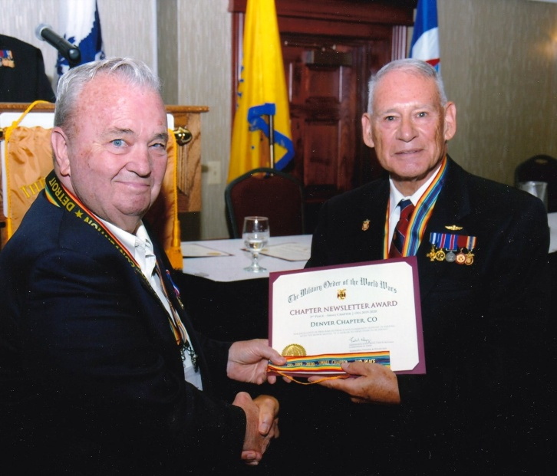

**(R) CINC, BGen Frederick R. Lopez, USMCR (Ret), presents the 3rd Place-Small Chapter Newsletter Award to (L) Denver Chapter Commander, LCDR Coy Ritchie, USN (Ret).**

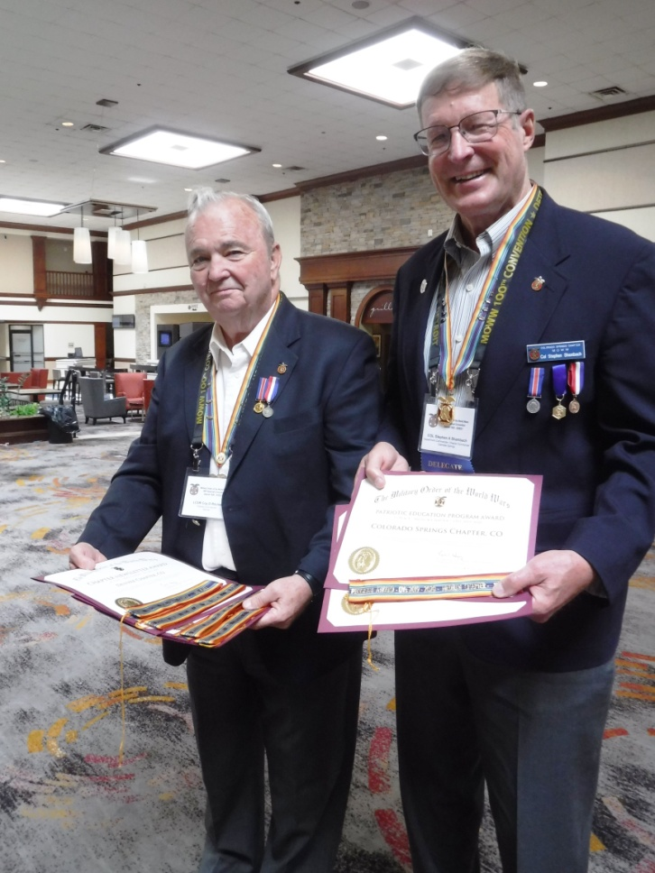

**(L) LCDR Coy Ritchie, Denver Chapter Commander, displays the four awards received by the Denver Chapter. (R) COL Steve Shambach, Rocky Mountain Department and Colorado Springs Chapter Commander displays the First Place Award his Chapter received for the Rocky Mountain Youth Leadership Conference.**

As noted above, the Denver Chapter received four Program Awards. These awards are shown below.

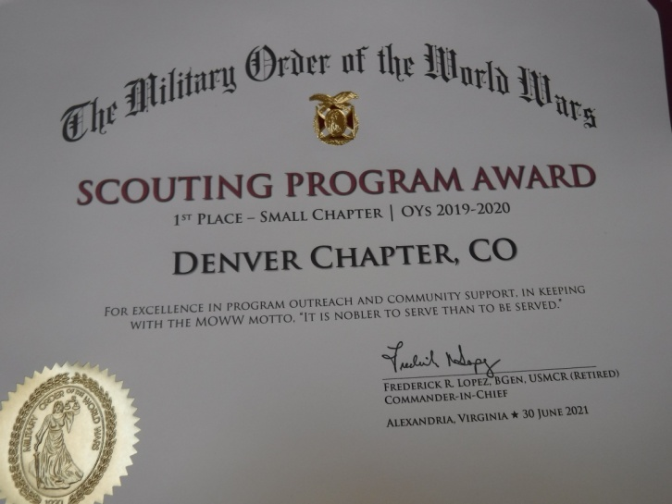

**Scouting Program Award, 1st Place, Small Chapter, Scouting Coordinator: LT Evan Totten, USNR (Fmr).**

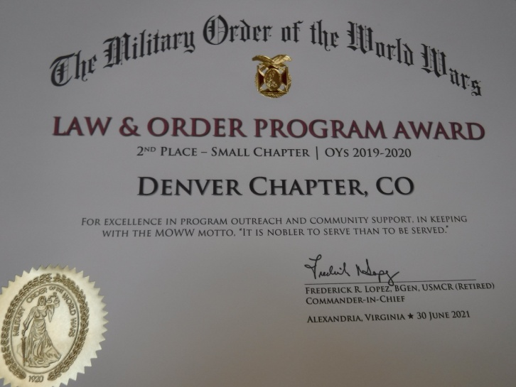

**Law & Order Program Award, 2nd Place, Small Chapter, Committee Chair: Col Ron Rakowsky, USAF (Ret).**

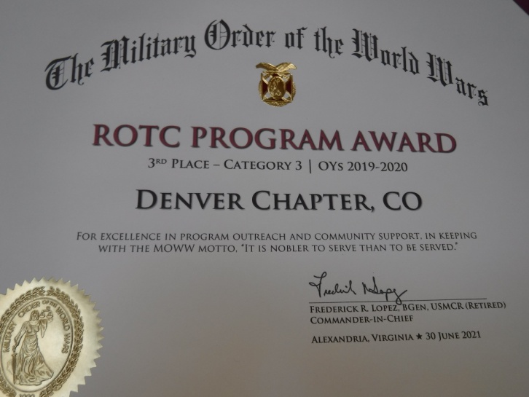

**ROTC Program Award, 3rd Place, Small Chapter, Committee Chair: LT Evan Totten, USNR (Fmr).**

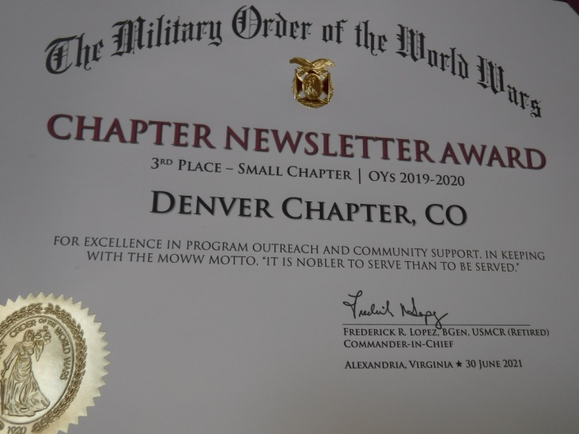

**Chapter Newsletter Award, 3rd Place, Small Chapter, Editor: LCDR Coy Ritchie, USN (Ret).**

Congratulations and thank you to everyone who contributed to the success of these four programs!

**POINTS OF CONTACT**

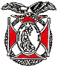**Denver Chapter (093), CO**

**Commander**

LCDR Coy Ritchie, USN (Ret)

4198 South Kirk Court

Aurora, CO 80013-6022

303-690-5118 (Res), 303-981-5519 (Cell)

[**coyritchie@aol.com**](mailto:coyritchie@aol.com)

**Adjutant**

HPM Frances Long

6278 S. Kearney Street

Centennial, CO 80111-4237

303-694-1079 (Res)

[grannyfrancene@netzero.net](mailto:grannyfrancene@netzero.net)

**Treasurer**

LCDR Coy D. Ritchie, USN (Ret)

4198 South Kirk Court

Aurora, CO 80013-6022

303-690-5118 (Res), 303-981-5519 (Cell)

[coyritchie@aol.com](mailto:coyritchie@aol.com)

**Commander, Rocky Mountains Department**

COL Steven A. Shambach, USA (Ret)

[shambachsm@msn.com](mailto:shambachsm@msn.com)

**Commander, Region XIII**

LTC Patrick C. Stolze, USA (Ret)

[pstolze40@gmail.com](mailto:pstolze40@gmail.com)

