**COMMANDER’S CORNER (10 MARCH 2022)**

As of today, we are still permitted to have sit-down inside meetings and the mandatory mask edict has been lifted. Therefore we are still planning to have a regular face-to-face General Membership Meeting on Saturday, 23 April 2022, starting at 11:30 A.M. The meeting will be held at Las Brisas Restaurant, 6787 S. Clinton Street, Greenwood Village, CO. Our speaker will be announced in next month’s newsletter.

To get there (Las Brisas Restaurant), if you are coming from east of I25, drive west on Arapahoe Road to South Clinton Street (about a block before you get to I25) and take a left turn. Do not turn on Clinton Court as the next street is South Clinton Street. The restaurant is located on the east side of the Target Store parking lot. If you are coming from west of I25, drive east on Arapahoe Road until you pass under I25. The first street on the right is South Clinton Street. Turn right and you will see the restaurant on the east side of the Target Store parking lot. If you get lost, you can call me at 303-981-5519 (cell) and I will try to get you un-lost.

Coy D. Ritchie, D.M.

LCDR, USN (Ret)

Denver Chapter Commander

***It is nobler to serve than to be served***



**STAFF MEETING (10 MARCH 2022)**

This meeting was conducted at the Ritchie Home and virtually via Zoom. The meeting was called to order at 1110 hours by Denver Chapter Commander LCDR Coy Ritchie. Also attending were Col Ron Rakowsky, CPT Robert Mallin, LT Evan Totten, HPM Frances Long, and HPM Pat Ritchie. Invocation was given by LT Totten followed by the Pledge of Allegiance led by LCDR Ritchie.

Minutes The minutes of the meeting on 10 February 2022 were approved on a motion by CPT Mallin and seconded by HPM Long.

Financials The Treasurer’s Report as of 31 January 2022 was submitted, noting the U.S. Bank fund balance of $6,374.34 and ENT Credit Union fund balance of $8,844.60. The Treasurer’s Report was approved on a motion by CPT Mallin and seconded by LT Totten.

Scouts LT Totten reported there will be no Banquet this year. He now has a list of 120 Eagle Scouts from the greater Metro Denver area that we will be awarding certificates this year. There has been no response from the Girl Scouts yet but LT Totten estimates there will be about 30 receiving the Gold Award. A motion was made by CPT Mallin and seconded by LT Totten to transfer funds from the General fund to the Scouting Fund for this purchase. Motion carried.

ROTC, JROTC LT Totten reported that he will soon need funds to purchase 72 certificates, folders, and medals for presentation to the cadets. A motion was made by CPT Mallin and seconded by Col Rakowsky to move sufficient funds from the General fund to the ROTC Fund to purchase the certificates, folders, and medals. Motion carried.

Patriotic Education LCDR Ritchie reported that this year’s Rocky Mountain Youth Leadership Conference will be held at the University of Colorado at Colorado Springs, 20-24 June 2022. The Chapter contributed $750 to sponsor students attending the Conference.

Public Safety and Law and Order Col Rakowsky reported that Captain Jodi Peterson, South Metro Fire Safety will receive the Chapter’s MOWW Silver Patrick Henry Medal. LCDR Ritchie and Col Rakowsky will present the award at the monthly South Metro Fire Safety meeting on 4 April 2022.

Membership/Recruiting Please continue efforts as we need at least one new member this year.

Hospitality The next General Membership Meeting will be held on Saturday, 23 April 2022 at Las Brisas Restaurant. Please bring your spouse and friends for a delicious Mexican lunch. We will order off of the menu.

Program/Speaker To be announced in the April Newsletter

Region XIII Nothing new to report.

Old Business Just continue to seek new members.

New Business LCDR Ritchie presented the Outreach Service Medal to LT Evan Totten.

Next Staff Meeting The next staff meeting will be held on 7 April 2022 starting at 1030 hours at the Ritchie home. It is planned to have backup by Zoom for those unable to attend in person.

Adjournment LCDR Ritchie adjourned the meeting at 1135 hours.



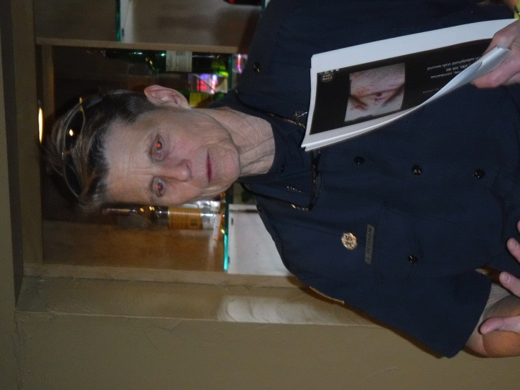

**At the luncheon on 19 February, Captain Jodi Peterson, Clinical Services Director, South Metro Fire Rescue gave a presentation on the point of care use of ultrasound as a practical tool in the pre-hospital setting.**

**COMING EVENTS (April & Later)**

* **STAFF MEETING (7 April 2022)**
  + (Thursday), 10:30 A.M.
  + Location: Ritchie Home plus Zoom

* **MOWW NATIONAL CONVENTION**

**(2-7 August 2022)**

* + Location: Jacksonville, Florida

Southbank Marriott Hotel 904-396-5100

* **MEMBERSHIP LUNCHEON**

**(23 April 2022)**

* + (Saturday), time 11:30 A.M.
  + Location: Las Brisas Restaurant, 6787 S. Clinton Street, Greenwood Village, CO.
  + Menu: Order from the menu and each individual will pay their own bill.
  + Program: To be announced in the April newsletter.



**THE TOXIC HOME**

CPT Robert E. Mallin, MD, USA (Fmr)

Surgeon General, MOWW

With the world’s dangers and complications, we usually feel safe at home. However, homes are two to five times more toxic than outdoors. The World Health Organization states up to 80% of all cancers are related to environmental issues—not genetics, e.g., carcinogenic chemicals in cleaning products. Almost three percent of the global “burden of disease” is due to air pollution, one way or another. Given that we spend up to 90% of our time inside some structure, this can lead to increased autism, allergies, “toxicity,” cancer and respiratory problems. Inadequate ventilation, lack of air conditioning and high humidity (over 50%) can increase the concentration of pollutants. Cooking and heating, candles, household cleansers, mold, mildew and toxins from building materials contribute to overall pollution.

**Some Specifics**:

*Radon is a noxious gas from the soil and bedrock beneath structures that can be in building materials, and may increase radium or uranium levels. This is the second highest cause of lung cancer, which is why Radon levels must be evaluated when selling houses.

*Tobacco smoke contains 200 known poisons and 43 compounds proven to cause cancer. Second hand smoke is believed to cause lung cancer deaths, and cardiovascular, respiratory and asthma problems. Pets and plants are also affected.

*Mold, mildew and viruses thrive indoors. These are serious problems, often very hard or impossible to remove, and may eventually cause one to move.

*Household Products The average home contains about 10 gallons of synthetic chemical products including pesticides, cleansers, paints, varnishes and air fresheners (including candles and incense) that distribute toxins throughout the home. Cleansers contain ethylene-based glycol ethers and terpenes. Ethers are toxic directly and terpenes interact with ozone to create a poisonous compound.

The foam in furniture and carpet backing emits many harmful chemicals continuously as does the glue holding these things and particle boards together. These volatile chemicals exist in levels two to five times higher indoors than outdoors. They are all linked to cancer, and heart and lung disease. Formaldehyde and PCBs (polychlorinated biphenyl) are emitted from many household products. Flame retardants contain polybrominated diphenyl ethers (PBDE). They have a variety of negative health effects. Flame retardants are used in computer and TV casings, circuitry, mattresses, kids’ pajamas and upholstery.

What can we do? First, we can eliminate sources where we can. Use organic products, regularly clean dirt build-up areas, e.g., air conditioners and furnaces. Ventilate adequately. Open windows and doors (even in the winter) to bring in fresh air. Wash and clean bedding and furniture coverings often. Steam cleaning helps. Second, houseplants are a great natural and effective way to remove pollutants from the home. The Victorians in their overstuffed homes realized this. Broad-leafed green plants work the best. Boston ferns, English ivy and rubber plants do a good job.

Be well.

*CPT (Dr.) Robert E. Mallin, USA (Former) is a graduate of Adelphi University and New York Medical College. He is certified with the American Board of Plastic and Reconstructive Surgery and is a Fellow of the American College of Surgeons. In private practice from 1975-94, he was the Alaskan State Physician of the Year. While in the U.S. Army (1966-1968) he earned a Bronze Star, Purple Heart and Air Medal, and a Combat Medical Badge.*

*The Military Order of the World Wars*

*THE OFFICER REVIEW, November-Decemberl 2016 p23*

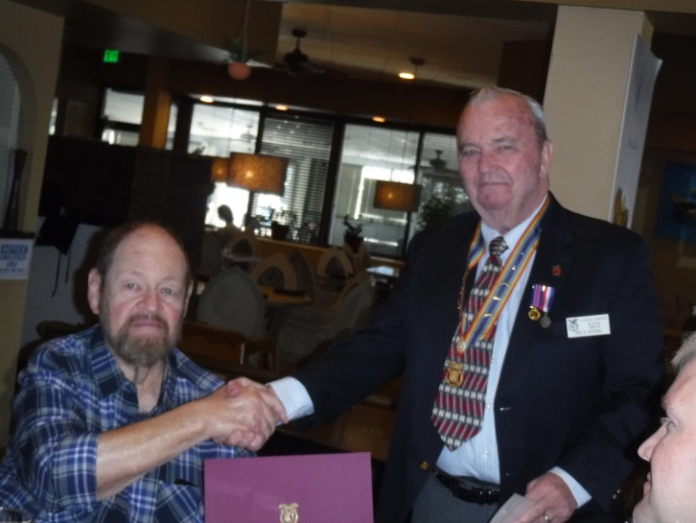

**CPT (MD) Bob Mallin (l) receives the MOWW Outstanding Service Medal from LCDR Coy Ritchie, Chapter Commander**

**THE CINC SOLICITATION**

The Commander in Chief is appealing to you to donate generously to the CINC Solicitation by making a *tax-deductible donation* in support of our Order’s patriotic and educational activities. He also asks that you encourage other Companions in your chapter to do so too. Our CINC Solicitation goal of $100,000 helps pay for activities such as:

* Supporting chapters via essential services (e.g., YLC insurance) and merchandise (i.e., products of all types)
* Existing awards, e.g., ROTC/JROTC Awards of merit, GSUSA Gold Award, and BSA Eagle Scout Certificates
* New awards, e.g., Outreach Service Medal and BSA Sea Scout, Quartermaster and Venture Scout Certificates
* Service Academy awards and military college awards
* Medals & certificates to ROTC/JROTC cadets & BSA & GSA scouts not supported by chapters
* Promotional material and program brochures for existing and start-up chapters
* The *Officer Review* magazine, which is MOWW’s only way to communicate with all Companions
* YLC Support via additional YLC issues of the *Officer Review* that YLC Directors use for advertising & recruiting
* The MOWW website at [www.moww.org](http://www.moww.org), which the Order’s Companions use in support of every activity area
* MOWW Convention Support, including the Distinguished Service and National Commander Award programs

It is very easy to contribute, just open up the Order’s web page and at the very top next to the logo is the DONATE tab. You can also mail in your contribution when you receive the solicitation in the mail from MOWW HQ.

Your tax-deductible donation supports patriotic activities only MOWW provides. *Please donate today!*

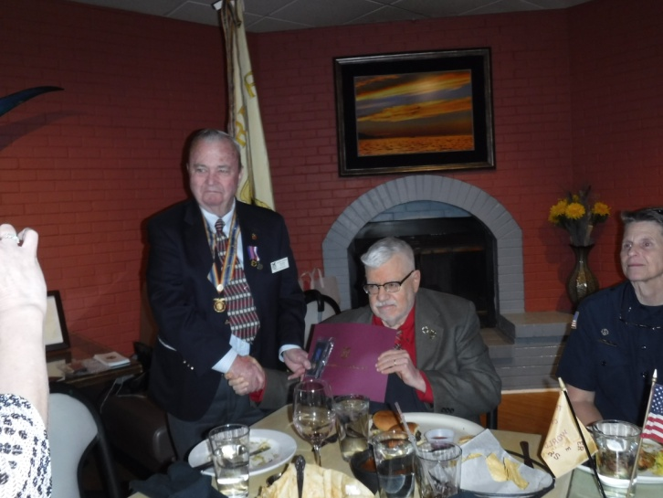

**Col Ron Rakowsky (center) receives the MOWW Outreach Service Medal from LCDR Coy Ritchie, Chapter Commander**

**POINTS OF CONTACT**

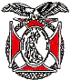**Denver Chapter (093), CO**

**Commander**

LCDR Coy Ritchie, USN (Ret)

4198 South Kirk Court

Aurora, CO 80013-6022

303-690-5118 (Res), 303-981-5519 (Cell)

[**coyritchie@aol.com**](mailto:coyritchie@aol.com)

**Adjutant**

HPM Frances Long

6278 S. Kearney Street

Centennial, CO 80111-4237

303-694-1079 (Res)

[grannyfrancene@netzero.net](mailto:grannyfrancene@netzero.net)

**Treasurer**

LCDR Coy D. Ritchie, USN (Ret)

4198 South Kirk Court

Aurora, CO 80013-6022

303-690-5118 (Res), 303-981-5519 (Cell)

[coyritchie@aol.com](mailto:coyritchie@aol.com)

**Commander, Rocky Mountains Department**

COL Steven A. Shambach, USA (Ret)

[shambachsm@msn.com](mailto:shambachsm@msn.com)

**Commander, Region XIII**

LTC Patrick C. Stolze, USA (Ret)

[pstolze40@gmail.com](mailto:pstolze40@gmail.com)