**COMMANDER’S CORNER (10 NOVEMBER 2022)**

We will have a regular face-to-face General Membership Meeting on Saturday, 17 December 2022, starting at 11:30 A.M. The meeting will be held at Las Brisas Restaurant, 6787 S. Clinton Street, Greenwood Village, CO. The featured speaker has not yet been confirmed. This being close to Christmas, the topic will probably be a religious one.

To get there (Las Brisas Restaurant), if you are coming from east of I25, drive west on Arapahoe Road to South Clinton Street (about a block before you get to I25) and take a left turn. Do not turn on Clinton Court as the next street is South Clinton Street. The restaurant is located on the east side of the Target Store parking lot. If you are coming from west of I25, drive east on Arapahoe Road until you pass under I25. The first street on the right is South Clinton Street. Turn right and you will see the restaurant on the east side of the Target Store parking lot. If you get lost, you can call me at 303-981-5519 (cell) and I will try to get you un-lost.

For planning purposes, Region XIII will be having

our next Conference January 18-20, 2023 in the Phoenix area. I will let you know the actual site as soon as I am informed. Pat and I plan to attend.

Coy D. Ritchie, D.M.

LCDR, USN (Ret)

Denver Chapter Commander

***It is nobler to serve than to be served***



**STAFF MEETING (10 November 2022)**

This meeting was conducted at Frances Long’s Home and was called to order at 1105 hours by Denver Chapter Commander LCDR Coy Ritchie. Also attending were LT Evan Totten, HPM Pat Ritchie and HPM Frances Long. CPT Bob Mallin, M.D. attended by Zoom. The Invocation was offered by LT Totten followed by the Pledge of Allegiance led by LCDR Ritchie.

Minutes The minutes of the meeting on 13 October 2022 were approved on a motion by LT Totten and seconded by HPM Pat Ritchie.

Financials The Treasurer’s Report as of 31 October 2022 was submitted by LCDR Ritchie. The month ended with a U.S. Bank fund balance of $6,822.47 and ENT Credit Union fund balance of $8,872.63. The Treasurer’s Report was approved on a motion by HPM Long and seconded by LT Totten.

Scouts LT Totten reported that communications have begun with the Greater Colorado Council to obtain the names of the Eagle Scout nominees from the Black Feather District.

ROTC, JROTC LT Totten reported that contacts have begun to obtain names of awardees and the dates for the presentation schedule.

Patriotic Education Nothing new to report.

Public Safety and Law and Order Nothing new to report.

Region XIII and Dept. of the Rocky Mountains LCDR Ritchie reported that there will be 3 Region XIII Conferences held in 2023. They will be: Hybrid Conference on January 18-20 in the Phoenix area, 3rd Qtr. Zoom Conference on 4/14/23 at 7:00 PM MDT, and Spring Hybrid Conference on June 15-16 in the Tucson area.

Membership/Recruiting LCDR Ritchie reported that the Chapter now has a new perpetual member, Capt Dennis Orr, USAF (Fmr)

Hospitality The next General Membership Meeting will be held on Saturday, 17 December 2022 at Las Brisas Restaurant. Please bring your spouse and friends for a delicious Mexican or Spanish lunch. We will order from the menu.

Program/Speaker The speaker has not been confirmed.

Old Business Nothing to report.

New Business The 2023 Chapter Budget was approved with the provision that it be flexible because of several expenses that are not confirmed at this point in time. Motion was made by HPM Long and seconded by LT Totten.

Next Staff Meeting Thursday, 8 December 2022 starting at 1100 hours at the home of Frances Long.

Benediction Offered by LT Totten.

Adjournment LCDR Ritchie adjourned the meeting at 1150 hours.

Submitted by HPM Frances Long, Adjutant



**COMING EVENTS (December & Later)**

* **STAFF MEETING (8 December 2022)**
  + (Thursday), 11:00 A.M.
  + Location: Frances Long Home

* **MOWW NATIONAL CONVENTION**

**(August 2023)**

* + Location: Annapolis, MD
* **MEMBERSHIP LUNCHEON**

**(17 December 2022)**

* + (Saturday), time 11:30 A.M.
  + Location: Las Brisas Restaurant, 6787 S. Clinton Street, Greenwood Village, CO.
  + Menu: Order from the menu.
  + Program: Not yet confirmed.



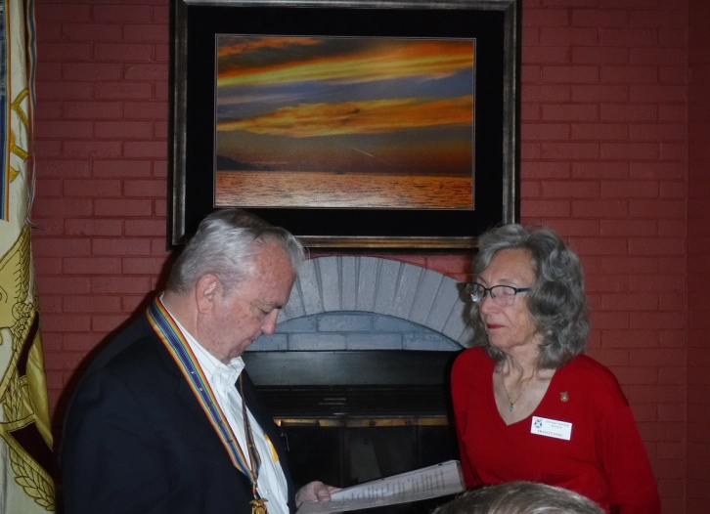

**HPM Francis Long (right) was in Scotland during the regular officer installation so she was installed as Adjutant by LCDR Ritchie at the Luncheon Meeting on 22 October 2022**

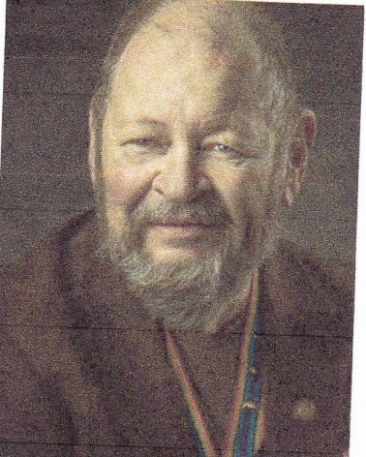

**Bob**

**OH, MY ACHIN’ BACK**

CPT Robert E. Mallin, MD, USA (Fmr)

Surgeon General, MOWW

People have asked me where I get the topics about which to write. Actually, in my Chapter, and likely yours, we continually realize we need more information about the different things that keep turning up. This go-round is the sciatic nerve and accompanying low back pain or as we often say, “My achin’ back!”

Sciatic pain is caused by irritation to the roots (nerves coming from the spinal cord) that make up the sciatic nerve and low back. Sciatic Pain can start behind the butt, down the back of the leg, to the ankle and foot. Mostly one leg is more symptomatic than the other, for me the left side is the worst. Common causes include bulging or ruptured spinal disc spaces. Sometimes the pain seems unbearable—as well as debilitating. Sitting, standing for long periods of time, or flexing the knee to the chest, can make it worse. Walking, lying down, and spine extension may help.

Doctors asking questions and doing simple examinations can make the diagnosis. However, finding causes, e.g., bone spurs, bulging discs, sometimes require X-rays and MRIs, Treatment: believe it or not, sometimes it just gets better by itself. Pain medications and directed exercises will help. Modern sports medicine and rehabilitation facilities are a Godsend. Medications include Tylenol, Advil, and Aleve.

The rehabilitation routine usually involves two to three sessions a week, with manipulation exercise and/or electric stimulation for 20 minutes. Remembering that the cause of pain is irritation, one must forget the “no pain, no gain” rule. Indeed, the ideal (recommended) approach is to do the prescribed exercises just short of pain. Admittedly, it is difficult to “settle” for discomfort as an outcome, but it is OK. Often things feel worse after exercises, but day-to-day improvement will generally happen. Exercises stretch the nerves, and limit the pressure of the pyramidal muscle. The various nerve roots join and a structured nerve comes through this muscle and easily gets irritated. The healing progress is slow.

My unrealistic goal many years ago was to drive 1,000 miles (round trip) to the Region XIII meeting in El Paso within two weeks of starting treatment. Even with stops every half hour, it was not easily or completely accomplished. My therapist says think in terms of two to three months, not weeks, to alleviate symptoms. Alternatively, standing, sitting and walking help. Heat and/or ice packs may help, also. One of those expensive mattresses such as I have may really help. If nothing else, relieve the pressure of your full wallet in the pocket over the nerve. Joking aside, the wallet in the typical back pocket does cause pressure and often pain, as it is just over the sciatic nerve emerging from the pyramidal muscle. Use the shirt or jacket pocket. The ultimate treatment involves steroid injections or as a last resort, surgery. Swallowing your pride and using a cane or walker helps, if one remembers to think of them as “temporary solutions.” And that some pain may just be a recurring condition. As Lincoln said in a speech before he was elected President, “This too shall pass.” Perhaps he should have said, “I want patience right away!” Be well / Bob

*MOWW OFFICER REVIEW April 2014 p19*

*The Military Order of the World Wars*

*CPT (Dr.) Robert E. Mallin, USA (Former) is a graduate of Adelphi University and New York Medical College. He is certified with the American Board of Plastic and Reconstructive Surgery and is a Fellow of the American College of Surgeons. In private practice from 1975-94, he was the Alaskan State Physician of the Year. While in the U.S. Army (1966-1968) he earned a Bronze Star, Purple Heart and Air Medal, and a Combat Medical Badge, among other decorations.*

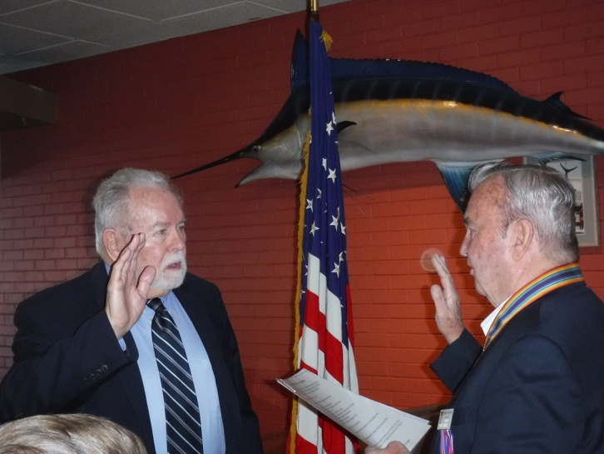

**Capt Dennis Orr, USAF (Fmr) (above left) is inducted as a regular member of the Denver Chapter by LCDR Coy Ritchie at the Membership Luncheon on 22 October 2022.**

**POINTS OF CONTACT**

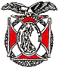**Denver Chapter (093), CO**

**Commander and Treasurer**

LCDR Coy Ritchie, USN (Ret)

4198 South Kirk Court

Aurora, CO 80013-6022

303-690-5118 (Res), 303-981-5519 (Cell)

[**coyritchie@aol.com**](mailto:coyritchie@aol.com)

**Adjutant**

HPM Frances Long

6278 S. Kearney Street

Centennial, CO 80111-4237

303-694-1079 (Res)

[grannyfrancene@netzero.net](mailto:grannyfrancene@netzero.net)

**Commander, Rocky Mountains Department**

COL Steven A. Shambach, USA (Ret)

[shambachsm@msn.com](mailto:shambachsm@msn.com)

**Commander, Region XIII**

LTC Patrick C. Stolze, USA (Ret)

[pstolze40@gmail.com](mailto:pstolze40@gmail.com)