Colorado Springs, CO Chapter #151
6 February 2022

Commander’s Corner:
Greetings, Companions!
Writing this right after the snowstorm and cold weather. Guess winter is finally here! I hope you and yours had a nice Christmas, Hannukah and New Year holiday time with your family. Still, lots of challenges from COVID, though.
On a sad note, one of our long-time members, COL (USAF, ret) Chaplain Robert Browning passed away in January. He was in the first graduating class from the US Air Force Academy and was senior pastor at the Church at Woodmoor. Mike Berendt represented our Chapter at the memorial service held at the US Air Force Academy and presented a condolence card to the family from our Chapter.
Your MOWW Chapter staff has been busy since the holidays. As always, we are looking forward to increasing our membership and companion participation in the New Year!
Significant activities in January:
- January 22nd, I attended the MOWW Region XIII Conference in Mesa Arizona. The Region Commander, Pat Stolze, hosted the conference and the MOWW CINC, LTC USA ret. Michael Okin, MD attended and provided an update on initiatives at the National Level. Key points from the Conference:
  - The following elements constitute a successful chapter:
    - Meetings
    - Communications
    - Succession planning. Really vital!
    - Recruitment-emphasize younger members
    - Note: As a chapter, we meet 3 of 4 elements. Recruitment continues to pose a daunting challenge requiring everyone’s help in identifying and recruiting prospective members.
  - MOWW Direction
    - MOWW has 6700 members. However, recruitment continues to challenge the organization. Declining membership is causing a reevaluation of our organization’s reason for existence.
    - We need younger companions to make MOWW a viable organization. The competing demands for time requires MOWW to work on our value proposition to make the organization more appealing to younger members who are balancing careers and family commitments. What can we do as a chapter to include more family friendly events that will include family participation? We need to evaluate if our Saturday meetings to facilitate this engagement. The winter meetings are conducive, but summer meetings may conflict with children’s activities that typically occur on Saturdays.
    - Diversity. Need a more diverse membership
    - Youth Leadership Conferences are important planks of our program to fulfill the preamble, i.e. “To promote and further patriotic education in our Nation” and “Transmit all these ideals to posterity.”
    - Headquarters hired a marketing firm as part of the evaluation of the organization. Departure Marketing. 1st meeting was January 13th. Goal: To give MOWW tools to help as we market locally. Still a Chapter’s job. Headquarters is reviewing the organization name and applicability going forward—does the name help or hinder the viability of the organization?
    - New Trifolds distributed to chapter commanders as an interim.
    - National website under reconstruction. Revisions will incorporate marketing firm recommendations. Cybersecurity process associated with accessing website and companion section under revision to protect Companion personal identifiable information (PII).
    - Headquarters reviewing organizational use of social media and will provide guidelines to ensure MOWW brand is synchronized among all the chapters for common themes and organizational objectives.
    - Headquarters reviewing the pros and cons in changing from 501(c)19 Veteran’s Service Organization to 501(c)3 Non-Profit Charitable Organization. One pro to transition to 501(c)3 will remove requirement to maintain veteran ratio as 501(c)19 to maintain tax exempt status. Another pro is to transition to 501(c)3 is to allow MOWW to solicit corporate sponsorship or donations.
    - Modernizing Constitution and Bylaws. Need a way to present changes to Companions more quickly vice only at the annual Convention.
    - As a Chapter we need to follow the tenets of a successful Chapter emphasizing the areas already presented.
    - Expand YLC solicitation to private and non-traditional schools vice only traditional public schools
- January 29th. Membership meeting: Presentation by COL (USA, ret) Rudy Veit and LTC (USA, ret) Nathan Watanabe, both J5 campaign planners at NORAD-NORTHCOM. They provided the Bi-Command brief and an update on current events. We had almost 40 attendees, which is the most we have had since I have been Chapter Commander! This meeting was not Zoomed, and slides were not available per request of the presenters.
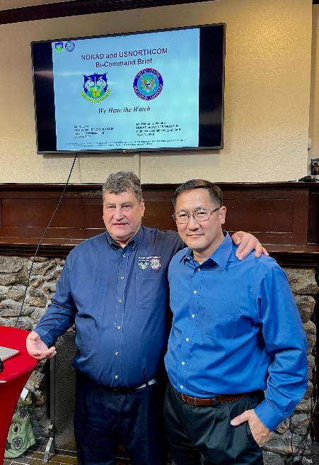
Rudy Veit (left) and Nathan Watanabe (right)

- The latest edition of Officer Review magazine featured an article in the Chapters in Action section, entitled “Operation Gothic Serpent, aka Blackhawk Down”. Mike Berendt wrote up the article reporting on the presentation by COL (USA, ret) Lee VanArsdale at our Membership Meeting last year. Good job Mike and thank you Lee!
- The Colorado Springs MOWW Chapter website continues to improve due to the hard work by Joani Sgaggio (spouse of LTC (ret) Mike Berendt)! The Chapter Website is: COS-MOWW.org. Note: Depending on search engine, if you use COS-MOWW the first web site you will return is the National website.

- Administrative

Member Birthdays: Best wishes for the following companions:
January: Lt Col Keith Woodfork, 2nd; Maj Justin Keller, 14th; Ms. Shirley Durham, 30th; Lt Col Anja Wynne, 30th.
February: Lt Col Susan Cooley, 2nd; Col Joe Morgan, 3rd; LT Col Robert Becerra, 4th; MG Tom Csrnko, 5th; Col Philip Madden, 8th; Maj Tim Matson, 18th; Maj Charles Clark, 22nd; Capt Douglas Katien-Taylor, 24th; 2 LT Isabel Taylor, 26th; Mr. Michael Wilson, 26th.
- Staff Reports
  - Monthly Staff Report. We held a Staff Meeting on 13 January. The following are items of interest:
  - Treasurer’s Report. Mike Berendt. (December)
CDs: | $12,157.36 |  | Expenses  Domain name for Chapter Website
Checking: | $101.10
Savings: | $5623.15
Total: | $17,881.62

Adjutant Membership Report-Ulysses Swift
Current number of members | 76 | Change since last month
Residing in Colorado | 66
Members over age 75 | 26
Members under age 75 | 50

4. Committee Reports

a. ROTC/JROTC- We need someone to take over this program. Contact Mike Berendt if you are interested in helping.

b. Patriotic Education- Steve submitted an article on our YLC for publication that should be published in an upcoming issue of Officer Review.

c. First Responders-Dr. George Reed. The Fireman’s Awards Banquet will be held on June 10th, and our chapter will sponsor a table. Also, it was recommended that we present an MOWW award to Chief Niske who is retiring after 30 years of service to the City of Colorado Springs culminating in his retirement as the Police Chief. The Chapter is extending an invitation to him to our February Membership Meeting where we can recognize his years of service to the City of Colorado Springs.

d. Programs-Steve Shambach

(1) February 26th: Randy Helms, a Colorado City Councilman and MOWW member, will address his experience as a city council member.

(2) March 19th: JROTC presentation.
(3) April TBD
(4) May TBD
(5) Note: Denver Chapter is holding their membership meeting at a luncheon on Saturday, 19 February. For details or information, contact the Denver Chapter Commander, LCDR Coy Ritchie, USN (Ret). 303-690-5118 (Res), 303-981-5519 (Cell) coyritchie@aol.com . We would like to support our companion chapter! Let him know if you are able to attend.
e. Rocky Mountain Youth Leadership Foundation (RMYLF) and RMYLC-Steve. High School liaisons have begun to contact high school guidance counselors and JROTC instructors to recruit rising High School Seniors for our 2022 Conference. If you know of any rising high school seniors for this conference, have them contact their high school counselor or JROTC instructor. Also, we are looking for volunteers to help prepare for and/or run the Conference. This year’s Conference will be held 20-24 June at the University of Colorado, Colorado Springs. If you would like more information, you may contact me or Anja Wynne, Cell: (719) 237-8019 or e-mail at thewynnegroup@comcast.net .
f. Scouts: MOWW will be presenting 10 Eagle Scout Certificates to members of Troop 194 from Falcon this month. We are also working to present the MOWW certificates at the Pathway to the Rockies Council’s annual Members Recognition banquet, currently scheduled for 24 May. More details to follow. We are also coordinating with Coy Ritchie and the Denver Chapter for the annual Colorado Girl Scout Gold Star awards.

5. New Business.

a. Election of new Chapter Officers. We will be accepting nominations to fill staff positions for our Chapter for Operating Year 2023, which begins July 2022 and ends 2023. We will accept either self-nominations or nominations of other Chapter Members. Positions to be filled are:
- Chapter Commander
- Senior Vice Commander
- Junior Vice Commander
- Adjutant
- Treasurer/Assistant Adjutant

Please contact me with nominations sometime this month.

b. In addition, we are soliciting from membership volunteers for the following vacant positions (please go to MOWW website for job descriptions if you are interested in these positions). These are non-elected positions.

(1) Historian (Priority Position Steve would like filled)

(2) Public Relations (Priority Position Steve would like filled)

(3) Marshall

(4) Chaplain

(5) Judge Advocate

6. Old Business

All Recruit new members! It was pointed out that we are 1/2 of the way through our fiscal year and our Colorado Springs Chapter has not recruited anyone yet! I need your help!! Again, the goal is for each of you to bring in one new member this year. Invite a prospective companion to an upcoming membership meeting.

Chapter needs to complete required documents for state tax exempt status using MOWW Federal 501(c)19 Veteran Tax Exempt status. Rich Peters and Mike Berendt are working on this initiative. National HQs is exploring Tax Exempt 501(c)3 status for entire organization.

We need to work up a Staff succession plan for the next 3 years. By our bylaws, this is last year for Commander and several others are on extension.

We can submit articles to Officer Review MOWW Magazine. It was suggested that we establish a Scribe Position.

Marketing and Outreach. Steve is on a National MOWW Strategic Initiatives committee. They are contracting a marketing organization to help MOWW improve their marketing.

7. Next Staff Meeting: Thursday, 24 February, 1700 at Hill House.

8. Next Chapter Meeting: Saturday, 26 February 2022

When: Social time at 1100 (cash bar); Call to Order at 1130; Lunch at 1145; Adjourn at 1330

Where: Patty Jewett Golf Course, 900 East Espanola, Colorado Springs, CO 80907

Speaker: Col (USAF, Ret) Randy Helms, currently a Councilman on the Colorado Springs City Council. Bio: A 1979 USAF Academy graduate, Councilman Randy Helms, Colonel USAF (Retired) was elected to the Colorado Springs City Council last April 2021 and is serving a four-year term. He represents District 2. He was currently elected by his fellow Council Members to serve as the City Council President Pro-Tem. Randy started his Air Force career as a T-39 instructor pilot and then transitioned to the C-141 where he was an instructor and evaluator airdrop pilot. He has held staff positions at USAF Academy, Pentagon Air Staff, the Joint Staff, Office of Secretary of Defense (OSD), USTRANSCOM, and National Defense University. Randy commanded the 76th Airlift Squadron at Ramstein Air Base, Germany and the 436th Operations Group at Dover AFB, DE. During his Air Force career Randy served as an Air Officer Commanding, Foreign exchange officer, USTRANSCOM Legislative Liaison and Chief, Commanders Action Group, and Deputy Director NDU CAPSTONE. Randy’s active-duty career culminated when he served as Chief of Staff, National Defense University. Upon his retirement in 2008, Randy worked on the civilian side of the USAF Air Staff, National Defense University and USAFA Foundation. Currently, Randy is a K-12 substitute teacher in Colorado Springs Academy School District 20 and the President of the USAFA Association of Graduates (AOG) Class Advisory Senate (CAS). As CAS President, he serves on the AOG Board of Directors. He is a volunteer with the Academy Ladies and Gentlemen Group and support the Academy 10th Medical Group to administer the COVID-19 vaccination. Randy and Donna were married in the Academy Cadet Chapel have been married more than 42 years. They have three adult children and five grandchildren.

Reservations Required: Please RSVP no later than 23 February 2022 to LTC Mike Berendt, berendt478@aol.com; (410)908 6777

Lunch Menu: TBD

Cost: $25.00 per person, cash or check only please

Attire: Casual for men; comparable for women. Wear your MOWW nametag and paraphernalia!

Questions? CONTACT: Stephen Shambach 719-447-5505 shambachsm@msn.com

For the Good of the Order.
Steve Shambach, COL, USA (Ret)
Colorado Springs Chapter Commander
H: 719.481.4776; C:719.447.5505
shambachsm@msn.com
“It is nobler to serve than to be served”
Attachment: Contribution/Pledge Form

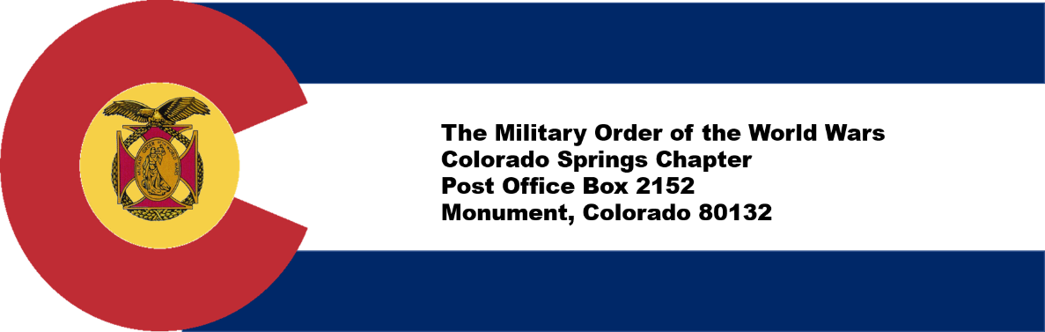

CONTRIBUTION OR PLEDGE
Yes, I am making a tax-deductible contribution or pledge to the Colorado Springs Chapter of the Military Order of the World Wars.

I wish to contribute or pledge $__________to the Patriotic Education Fund.

I wish to contribute or pledge $__________to the ROTC Fund.

I wish to contribute or pledge $__________to the Boy and Girl Scout Fund.

I wish to contribute or pledge $__________to the Law & Order Fund.

I wish to contribute or pledge $__________to the Operations Fund (postage, bulletin, directory, recognition programs – plaques, medals, etc.)

___________________________________________________________________
Name
Please make checks payable to Colorado Springs Chapter, MOWW
Send to: LTC Mike Berendt
1230 Bowstring Road
Monument, CO 80132

