**COMMANDER’S CORNER (10 FEBRUARY 2022)**

Today’s Staff Meeting was originally scheduled to be held at the Ritchie home, but to facilitate attendance by those unable to attend in person, we also had the meeting on Zoom. Guess what happened? All attendees (except Pat and I) decided to attend via Zoom. During the meeting, we agreed to have our next Staff Meeting as an in-person meeting on Thursday, 10 March 2022. However, the plan is to also have Zoom as a backup for those unable to attend in person.

As of today, we are still permitted to have sit-down inside meetings and the mandatory mask edict has been lifted. Therefore we are still planning to have a regular face-to-face General Membership Meeting on Saturday, 19 February 2022, starting at 11:30 A.M. The meeting will be held at Las Brisas Restaurant, 6787 S. Clinton Street, Greenwood Village, CO. Our speaker will be Captain Jodi Peterson, Clinical Director of Emergency Medical Services (EMS) at South Metro Fire Rescue. This should be a very interesting presentation on the use of Ultrasound in EMS. This would be an excellent time to invite a prospective member to our luncheon.

To get there (Las Brisas Restaurant), if you are coming from east of I25, drive west on Arapahoe Road to South Clinton Street (about a block before you get to I25) and take a left turn. Do not turn on Clinton Court as the next street is South Clinton Street. The restaurant is located on the east side of the Target Store parking lot. If you are coming from west of I25, drive east on Arapahoe Road until you pass under I25. The first street on the right is South Clinton Street. Turn right and you will see the restaurant on the east side of the Target Store parking lot. If you get lost, you can call me at 303-981-5519 (cell) and I will try to get you un-lost.

Coy D. Ritchie, D.M.

LCDR, USN (Ret)

Denver Chapter Commander

***It is nobler to serve than to be served***



**STAFF MEETING (10 FEBRUARY 2022)**

This meeting was conducted virtually via Zoom. The meeting was called to order at 1045 hours by Denver Chapter Commander LCDR Coy Ritchie. Also attending were Col Ron Rakowsky, CPT Robert Mallin, LT Evan Totten, HPM Frances Long, and HPM Pat Ritchie. Invocation was given by LT Totten followed by the Pledge of Allegiance led by LCDR Ritchie.

Minutes The minutes of the meeting on 6 January 2022 were approved on a motion by CPT Mallin and seconded by LT Totten.

Financials The Treasurer’s Report as of 31 January 2022 was submitted, noting the U.S. Bank fund balance of $6,630.02 and ENT Credit Union fund balance of $8,844.60. The Treasurer’s Report was approved on a motion by LT Totten and seconded by CPT Mallin.

Scouts LT Totten reported there will be no Banquet this year. Scouting officials sent a list of 407 Eagle Scout awardees for all of northern Colorado including 23 female Scouts. The cost of preparing over 400 awards will exceed $2,000 and our treasury cannot afford this. LT Totten will request the names of just those Scouts located in the greater Metro Denver area and we will revisit the topic at the next meeting.

ROTC, JROTC LT Totten reported that he will soon need funds to purchase certificates, folders, and medals for presentation to the cadets. We need member volunteers to present these awards.

Patriotic Education LCDR Ritchie reported that this year’s Rocky Mountain Youth Leadership Conference will be held at the University of Colorado at Colorado Springs, 20-24 June 2022. The Chapter contributed $750 to sponsor students attending the Conference.

Law and Order Col Rakowsky reported that he is selecting a candidate for nomination as the recipient of the Chapter’s MOWW Silver Patrick Henry Medal.

Membership/Recruiting Please continue efforts as we need at least one new member this year.

Hospitality The next General Membership Meeting will be held on Saturday, 19 February 2022 at Las Brisas Restaurant. Please bring your spouse and friends for a delicious Mexican lunch. We will order off of the menu.

Program/Speaker Captain Jodi Peterson, Clinical Director of Emergency Medical Services at South Metro Fire Rescue, will speak on the use of Ultrasound in emergency medical situations.

Region XIII LCDR Ritchie & HPM Pat Ritchie were unable to attend due to an emergency car situation. CPT Mallin was able to represent our Chapter via Zoom.

Old Business Just continue to seek new members.

New Business LCDR Ritchie reported that the MOWW National Convention will be held during 2-7 August 2022 in Jacksonville, FL.

Next Staff Meeting The next staff meeting will be held on 10 March 2022 starting at 1030 hours at the Ritchie home. It is planned to have backup by Zoom for those unable to attend in person.

Adjournment LCDR Ritchie adjourned the meeting at 1140 hours.



**COMING EVENTS (February & Later)**

* **STAFF MEETING (10 March 2022)**
  + (Thursday), 10:30 A.M.
  + Location: Ritchie Home plus Zoom

* **MOWW NATIONAL CONVENTION**

**(2-7 August 2022)**

* + Location: Jacksonville, Florida

Southbank Marriott Hotel 904-396-5100

* **MEMBERSHIP LUNCHEON**

**(19 February 2022)**

* + (Saturday), time 11:30 A.M.
  + Location: Las Brisas Restaurant, 6787 S. Clinton Street, Greenwood Village, CO.
  + Menu: Order from the menu and each individual will pay their own bill.
  + Program: Captain Jodi Peterson of the South Metro Fire Rescue speaking on the use of Ultrasound in emergency medical situations.



THIS ARTICLE IS NOT ABOUT YOU

CPT Robert E. Mallin, MD, USA (Fmr)

Surgeon General, MOWW

Do not be disturbed, this monthly offering is about the other people in our Order who we may suspect are aging…not you. Such people do not feel the every morning enthusiasm and “go get em” attitude that we do. No pain or “flabby muscles” greet us in the mirror. However, some people need to consider the passing of time. We have already established that age has little to do with being effective in life and MOWW. So that being said, let us move on.

How can we help our friends? A conversation with a Companion who recently lost his wife acknowledged that he has no further need for his three-story, four-bedroom house. He is investigating assisted living, which provides help when and if you need it, and one can be as independent as one wants. There are other considerations, though. How far is our aging friend from his loving family, grandchildren, etc.? Is being “close” a question of a plane ride or a six hour drive (as it is for me), or are they just a few minutes away? I am, personally, at the stage where I would rather and did trade in my big, unneeded house for the comfort of a smaller, manageable rental. In that way, someone else gets to shovel the drive, fix the air conditioner, or even get on that high ladder to clean the rood gutters, or change a ceiling light bulb.

That “friend” of ours might consider getting into a comfortable, manageable dwelling. No steps and a low entry shower are possible. (Few people use a tub these days.) While beautiful, living in the country is not the place to be when driving becomes a problem. In New Mexico, one had to re-qualify for a driving license yearly over the age of 75. It was no big deal—just a visual test—but this requirement signifies changes in our body machine. Volunteer positions, an MOAA chapter, and fitness facilities (especially a warm water pool with ramp entry) were essential for me. Our friend will need handy shopping, restaurants, lounges, etc. Those other people may appreciate closeness, as traveling distances may not be as welcome as before. When I was a kid, I pleaded with my Mom to do all the errands possible that required driving our floor shift Buick. I, personally, do not look forward to numerous trips these days. Instead, I try to bundle them, hopefully in a nearby location.

What I am saying is that modern society’s goal is to make things handy and our evolving needs are often complementary. Take advantage of this in your (or your friend’s) future planning. There is a tendency not to fix the leak in the roof when it is not raining. Sometimes, reversing this approach is helpful when planning. Use the “dry time” to fix the leak. Appreciate what my father used say, “you will never be this young again.” In addition, help your friends plan for the future while they still have choices because when you are not capable of making choices, others will do it for you—and that’s not always an ideal situation. Be well.

Bob

*CPT (Dr.) Robert E. Mallin, USA (Former) is a graduate of Adelphi University and New York Medical College. He is certified with the American Board of Plastic and Reconstructive Surgery and is a Fellow of the American College of Surgeons. In private practice from 1975-94, he was the Alaskan State Physician of the Year. While in the U.S. Army (1966-1968) he earned a Bronze Star, Purple Heart and Air Medal, and a Combat Medical Badge.*

*The Military Order of the World Wars*

*OFFICER REVIEW April 2016 p22*

**THE CINC SOLICITATION**

The Commander in Chief is appealing to you to donate generously to the CINC Solicitation by making a *tax-deductible donation* in support of our Order’s patriotic and educational activities. He also asks that you encourage other Companions in your chapter to do so too. Our CINC Solicitation goal of $95,000 helps pay for activities such as:

* Supporting chapters via essential services (e.g., YLC insurance) and merchandise (i.e., products of all types)
* Existing awards, e.g., ROTC/JROTC Awards of merit, GSUSA Gold Award, and BSA Eagle Scout Certificates
* New awards, e.g., Outreach Service Medal and BSA Sea Scout, Quartermaster and Venture Scout Certificates
* Service Academy awards and military college awards
* Medals & certificates to ROTC/JROTC cadets & BSA & GSA scouts not supported by chapters
* Promotional material and program brochures for existing and start-up chapters
* The *Officer Review* magazine, which is MOWW’s only way to communicate with all Companions
* YLC Support via additional YLC issues of the *Officer Review* that YLC Directors use for advertising & recruiting
* The MOWW website at [www.moww.org](http://www.moww.org), which the Order’s Companions use in support of every activity area
* MOWW Convention Support, including the Distinguished Service and National Commander Award programs

It is very easy to contribute, just open up the Order’s web page and at the very top next to the logo is the DONATE tab. You can also mail in your contribution when you receive the solicitation in the mail from MOWW HQ.

Your tax-deductible donation supports patriotic activities only MOWW provides. *Please donate today!*

**POINTS OF CONTACT**

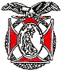**Denver Chapter (093), CO**

**Commander**

LCDR Coy Ritchie, USN (Ret)

4198 South Kirk Court

Aurora, CO 80013-6022

303-690-5118 (Res), 303-981-5519 (Cell)

[**coyritchie@aol.com**](mailto:coyritchie@aol.com)

**Adjutant**

HPM Frances Long

6278 S. Kearney Street

Centennial, CO 80111-4237

303-694-1079 (Res)

[grannyfrancene@netzero.net](mailto:grannyfrancene@netzero.net)

**Treasurer**

LCDR Coy D. Ritchie, USN (Ret)

4198 South Kirk Court

Aurora, CO 80013-6022

303-690-5118 (Res), 303-981-5519 (Cell)

[coyritchie@aol.com](mailto:coyritchie@aol.com)

**Commander, Rocky Mountains Department**

COL Steven A. Shambach, USA (Ret)

[shambachsm@msn.com](mailto:shambachsm@msn.com)

**Commander, Region XIII**

LTC Patrick C. Stolze, USA (Ret)

[pstolze40@gmail.com](mailto:pstolze40@gmail.com)

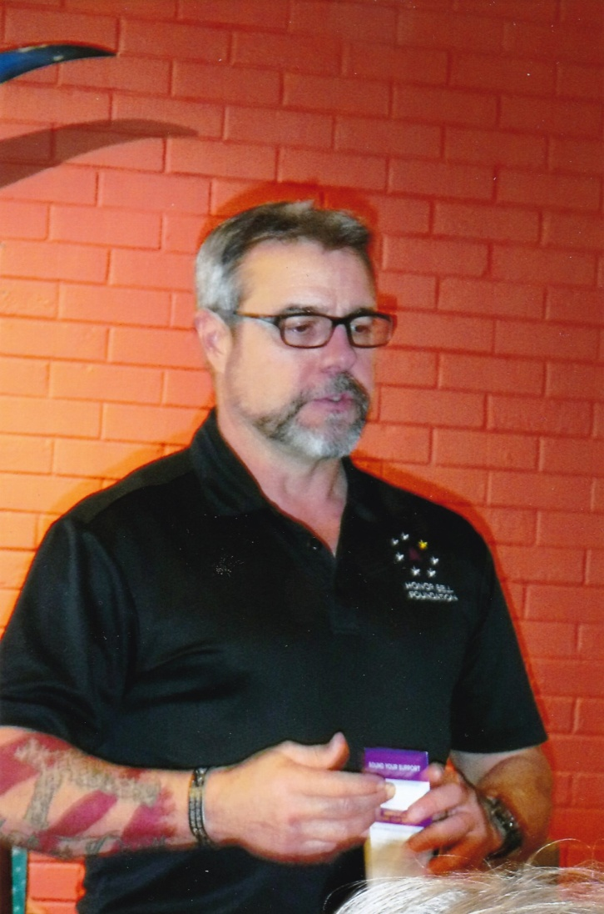

**Chris Boyer, CEO of the Honor Bell Foundation, speaks to the Chapter about the Honor Bell Foundation mission and activities during the Membership Luncheon on 17 December 2021**

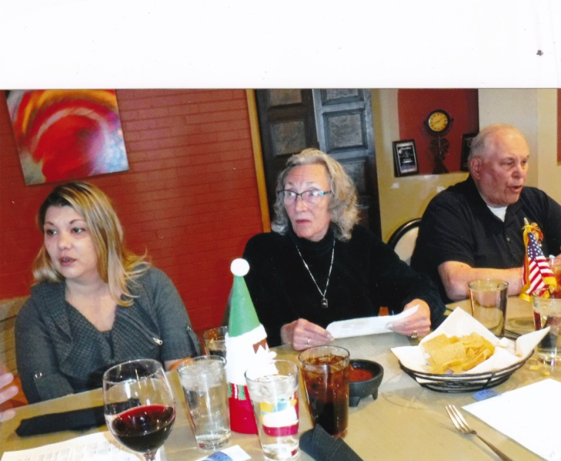

**(L to R) HPM Stephanie Ritchie, HPM Frances Long and LT Evan Totten attending the Membership Luncheon on 17 December 2021**

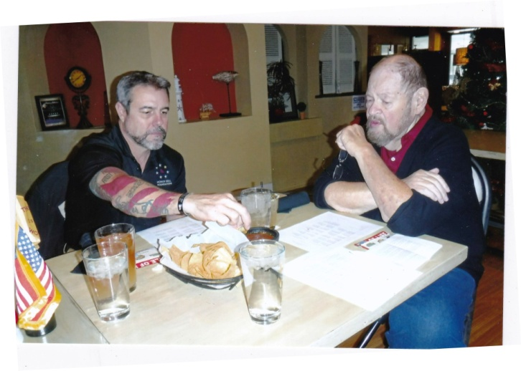

**Chris Boyer and CPT Bob Mallin, MOWW Surgeon General, discuss the Honor Bell Foundation**

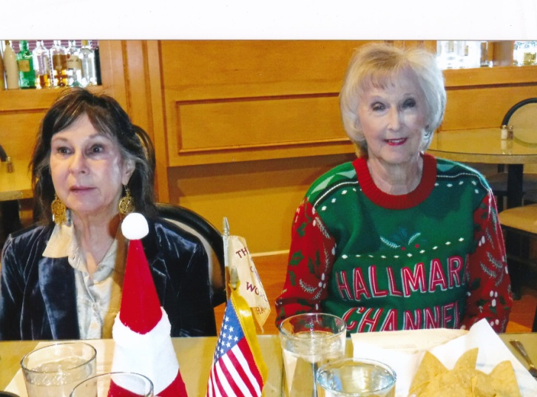

**(L to R) HPM Francis Fernandes and Janell Totten attending the Membership Luncheon on 17 December 2021**