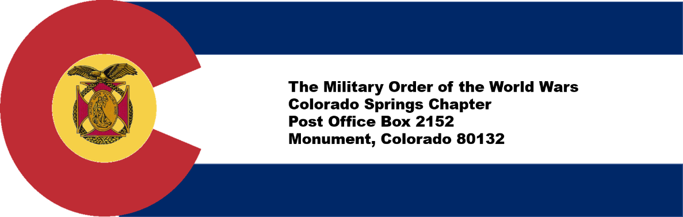

Colorado Springs, CO Chapter #151
10 August 2022

Commander’s Corner:
I just returned from the MOWW National Convention in Jacksonville, FL, 3-6 August, accompanied by my wife. It was a great experience and I encourage each of you to consider attending the next Convention in Annapolis, MD in 2023. I will post a detailed report on our Chapter Website. Of particular interest, our Chapter was awarded several certificates and streamers for outstanding performance in the Medium Chapter Category:
- Most Outstanding Patriotic Education Program-1st Place (Primarily Youth Leadership Conference)
- Most Outstanding Overall Chapter-3rd place
- Boy and Girl Scout Program. Medium Chapter, 3rd place

We achieved 100% of our chapter recruiting goal, which less than half the chapters accomplished. I would like to particularly thank the staff who worked hard throughout the year to run programs, document results and submit applications for recognition. With your help, we can continue the success of the past year and improve in the future.

Last month’s MOWW membership meeting featured several important activities:
First, we welcomed new member Col (USA, ret) Mark Weinerth, who joined us as a result of Paul Willey’s efforts.

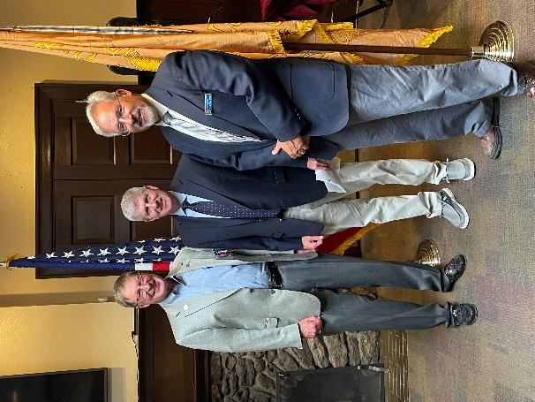
Paul Willey (L) and Steve Shambach (R)
welcome new member Col (USA, ret) Mark Weinerth

Next, we presented the following awards:

- Outreach Service Medals presented to Col Kerm Neal (USAF, ret) for leading the Boy and Girl Scout Program and Lt Col Ulysses Swift (USAF, ret) for his work with the ROTC/JROTC program.
- Silver Patrick Henry Awards to: Col (USAF, ret) RF Smith for his tremendous work as RMYLF President and Registrar for the RMYLC. Also, LTC (USAF, ret) Rich Peters, our outgoing Senior Vice, in recognition for his impact for the past two years in that position. In addition, Rich was presented with a National Citation from National MOWW HQs recognizing his contributions.

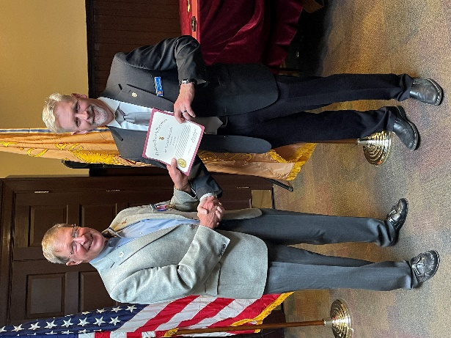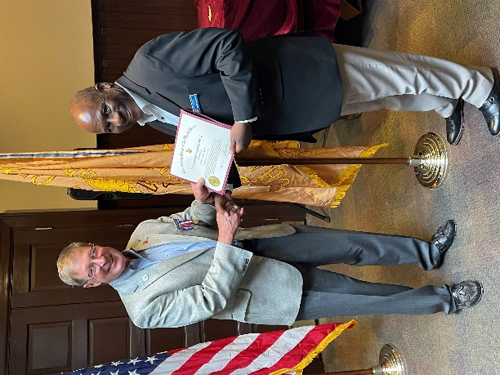
Steve Shambach presents Steve Shambach presents
Outreach Service Medal to Outreach Service Medal to
Kerm Neal Ulysses Swift

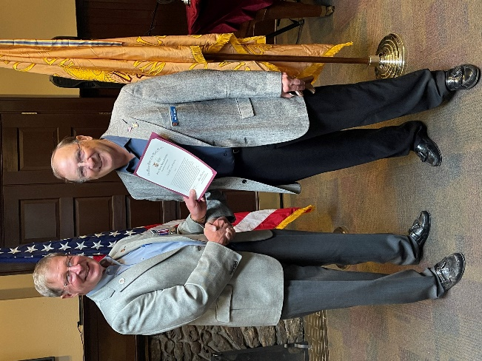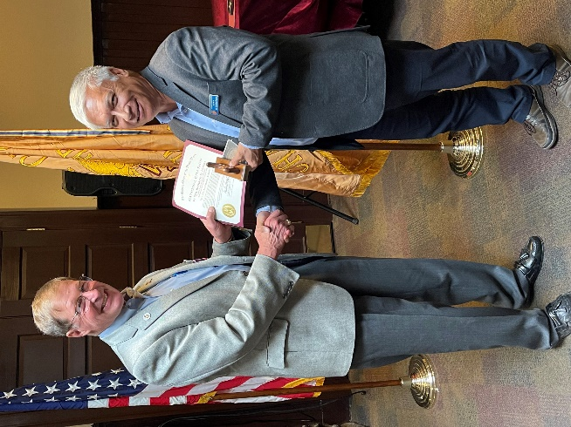
Steve Shambach presents Steve Shambach presents
Silver Patrick Henry to RF Smith Silver Patrick Henry to Rich Peters

The other major activity consisted of the installation of the Chapter Officers for OY 2022-2023.
- Chapter Commander, Steve Shambach
- Senior Vice Commander-Kerm Neal
- Junior Vice Commander-Rich Peters
- Adjutant-Ulysses Swift
- Treasurer and Assistant Adjutant-Mike Berendt

All of these officers also served in 2021-2022, so we will be looking for you to volunteer for leadership positions next year! We will also continue to have George Reed head up the First Responders Program and Jon Wisham the Homeland Security Program. We need someone to run the National Security Program. Let me know if you can help us.

We were honored to have LCDR Coy Ritchie, (USN, ret) serve as our installing officer and also as our guest speaker. He provided very interesting experiences from his time in the Navy, not the least of which is the 21 ½ gun salute!

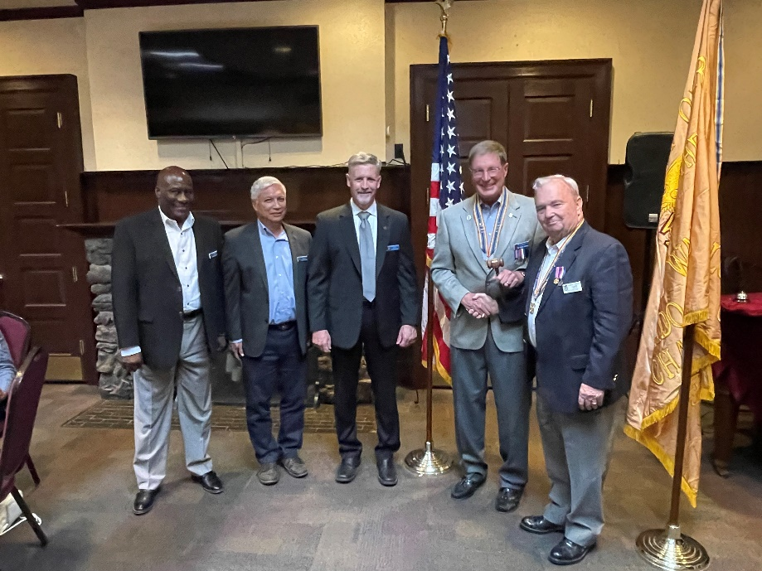
Chapter Commander and Staff Officers installed for OY 2022-2023
L to R: Ulysses Swift, Rich Peters, Kerm Neal, Steve Shambach
and installint officer, Coy Ritchie, Denver Chapter Commander

Looking ahead, we have a terrific program for August. Our speaker is Dr. Mary Kelly who will be speaking about leadership in these challenging economic times, both now and in the future.
In September, we are supporting a major fund raiser at the Flying W Ranch for our Youth Leadership Conference. We need everyone to attend, bring guests and host a table, if possible. We need lots of funding and sponsor support for this event as well as volunteers. Please help. Flyer attached. We are looking for: Table hosts for tables of 12; donation of a table; or individual/group tickets. Information is at Attachment 1. Note: You cannot use the link in this attachment to order tickets. You can order tickets at the Flipcause ticket widget; https://www.flipcause.com/widget/MTU0NzI3

- Administrative

Member Birthdays: Best wishes for the following companions:
August: Maj William Cross - 14 Aug; Col Robert Emmons - 21 Aug; Ms. Margaret Clay - 22 Aug; Col (Randy) Michael Helms - 25 Aug

September: LTC Francis Wynne - 7 Sept; CPT George Gay - 13 Sept; Mr. Curt Reus - 24 Sept; COL Stephen Shambach - 29 Sept; Ms. Stephanie Johnson - 29 Sept; COL Edward Fisher - 30 Sept

- Staff Reports
  - Monthly Staff Report. Staff Meeting held on July 14th . The following are items of interest:
  - Treasurer’s Report. Mike Berendt. (July)
CDs: | $12,253.32
Checking: | $4,523.35
Savings: | $101.13
Total: | $16,877.80

Adjutant Membership Report-Ulysses Swift
Current number of members | 81
Residing in Colorado | 69
Members over age 75 | 23
Members below age 75 | 58
  - Any overdue dues; None
  - Applications received: Linda Rowe, Jim Borders and Dick Liccardi
  - Materials received for new members: Yes. William Shambach, Valerie Warner and Mark Weinerth

4. Committee Reports
  - ROTC/JROTC-Mike/Ulysses. Mike Berendt reported that 21 awards costing $300 were presented for ROTC/JROTC certificates and awards. Attendees agreed we should standardize this practice to provide donors with information on how funds were used so that donors will support future donation requests.
  - Patriotic Education-Steve. See RMYLC notes.
  - Programs-Steve Shambach
    - Boy and Girl Scouts: Kerm Neal submitted Form 14 to MOWW HQs recognizing 29 Boy Scout Eagle Scout Awards and 13 Girl Scout Gold Awards. MOWW also participated in the Annual Pathway to the Rockies Awards Banquet.
    - First Responders – Firefighter First Responder Annual Awards Banquet– Mike Berendt and Rich Peters attended the banquet. Chapter received recognition as one of the “Captain” level sponsors (other levels were Chief’s Council and Lieutenant). Captain level included Children’s Hospital Colorado, Huntington Bank, Colorado College and University of Colorado, Colorado Springs School of Public Affairs. Banquet was well attended. Meeting attendees recommended we consider sponsoring Police and Fire Department banquets in alternate years with an exception to support both organizations in 2022. The Chapter provided a donation of $1750 for Captain level support at Firefighter Banquet and Award Ceremony. We also will sponsor the Police Foundation of Colorado Spring at the Sergeant level for $1,100 in September. The Medal of Valor Banquet for the COS Police Department will be held on 23 September 2022 -- MOWW will fill six seats with four police officers as our guests.

d. Homeland Security/National Defense- NSTR.

e. Rocky Mountain Youth Leadership Foundation (RMYLF) and RMYLC
i. Patriotic Education-Rocky Mountain Youth Leadership Conference 2022 completed. Submitted
report to National for reimbursement.

ii. RMYLF Fund raiser Tuesday, 27 September, 1700-2100 at Flying W Ranch. Need all hands!

7. Recruiting New Members! We need your help to recruit new members for the new Operating Year, which started 1 July. I am asking each member to identify at least one person to recruit this year!

8. Volunteer Solicitation. We are soliciting from membership volunteers for the following vacant positions (please go to MOWW website for job descriptions if you are interested in these positions). These are non-elected positions.

Historian (Priority Position Steve would like filled)

Public Relations (Priority Position Steve would like filled)

Marshall

Chaplain

Judge Advocate

9. Next Staff Meeting: Tuesday, 30 August, 1600 prior to the Chapter Dinner at Patty Jewett.

10. Next Chapter Meeting: Tuesday, August 30th, 2022

When: Social time at 1700 (cash bar); Call to Order at 1730; Dinner at 1745; Adjourn at 1930

Where: Patty Jewett Golf Course, 900 East Espanola, Colorado Springs, CO 80907

Speaker: Dr. Mary Kelly, US Navy Ret., Ph.D. CEO of Productive Leaders
Bio: Mary is a graduate of the US Naval Academy, and she served 21 years on active duty as an intelligence and a logistics officer, mostly in Asia. She earned a PhD in economics, and she taught at the Naval Academy, the Air Force Academy, and in the graduate school for Colorado State University. Author of 15 business and leadership books including The Five Minute Leadership Guide, 15 Ways to Grow Your Business in Every Economy, Money Smart, Why Leaders Fail and the 7 Prescriptions for Success, 5-Minutes Per Week, and 52 Weeks to Building a Better Business, and Who Comes Next? Leadership Succession Planning Made Easy, Mary is usually found around dogs and wine.
Reservations Required: Please RSVP no later than Thursday, 25 August to LTC Mike Berendt, berendt478@aol.com; (410)908 6777 and CC: Steve Shambach, shambachsm@msn.com; (719)447-5505
Cost: $25.00 per person, cash or check only please

Attire: Casual for men; comparable for women. Wear your MOWW nametag and paraphernalia!

11. Upcoming Events

September 27th, Tuesday, 1700-2100, Party at the Ranch, Fund Raiser at the Flying W for our Youth Leadership Conference

October 27th, Thursday, 1700-1930, UCCS ROTC Presentation, Patty Jewett Golf Course

November Veteran’s Day Recognition, TBD

December Pearl Harbor Day Recognition TBD

For the Good of the Order.

Steve Shambach, COL, USA (Ret)
Colorado Springs Chapter Commander
H: 719.481.4776; C:719.447.5505
shambachsm@msn.com
“It is nobler to serve than to be served”
Attachments:
1. Flyer for “Party at the Ranch” Fund Raiser
2. Contribution/Pledge Form

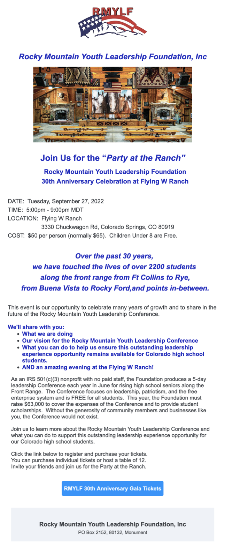

CONTRIBUTION OR PLEDGE
Yes, I am making a tax-deductible contribution or pledge to the Colorado Springs Chapter of the Military Order of the World Wars.

I wish to contribute or pledge $__________to the Patriotic Education Fund.

I wish to contribute or pledge $__________to the ROTC Fund.

I wish to contribute or pledge $__________to the Boy and Girl Scout Fund.

I wish to contribute or pledge $__________to the Law & Order Fund.

I wish to contribute or pledge $__________to the Operations Fund (postage, bulletin, directory, recognition programs – plaques, medals, etc.)

___________________________________________________________________
Name
Please make checks payable to Colorado Springs Chapter, MOWW
Send to: LTC Mike Berendt
1230 Bowstring Road
Monument, CO 80132

