COMMANDER’S LOG

Ukraine. The invasion of the country by the Russians is a top story in the news. They appeared to think that this would be any easy effort and the country would quickly surrender. After weeks of fighting, the Russian forces have not been able to accomplish their apparent goals of capturing Kyiv and replacing the Ukrainian government. The under equipped Ukrainian fighters have inflicted heavy losses of personnel and equipment on the Russians. Meanwhile, the Russians have inflicted heavy losses using nighttime air and missile attacks and artillery barrages on the Ukrainian cities including those far from the front. By now, about ten percent of the Ukraine population, mostly women and children, have fled the country to safety in Poland and adjacent countries.

How does this affect us? The U.S. is providing over a billion dollars of military aid and arms to the Ukrainians drawing down supplies here and in Europe. Thousands of soldiers have been deployed to our allies in Eastern Europe and the Baltic States. President Biden has authorized 100,000 of the refugees to come to the U.S. Because Russia is one of the largest oil exporters in the world, the boycott of Russian oil has driven the world prices to near record levels. Other impact may yet be seen.

The credibility of U.S. promises is on the line. Allowing Russia to conquer Ukraine can lead to them attacking and trying to conquest other former Soviet states including the Balkans and other Eastern European countries that were part of the Soviet Block. China might feel that it can attack and take over Taiwan and other neighbors. These adventurist moves could lead to the U.S. returning to combat even to World War III. This current fighting could lead to severe impacts to us all.

THIS MONTH’S EVENTS

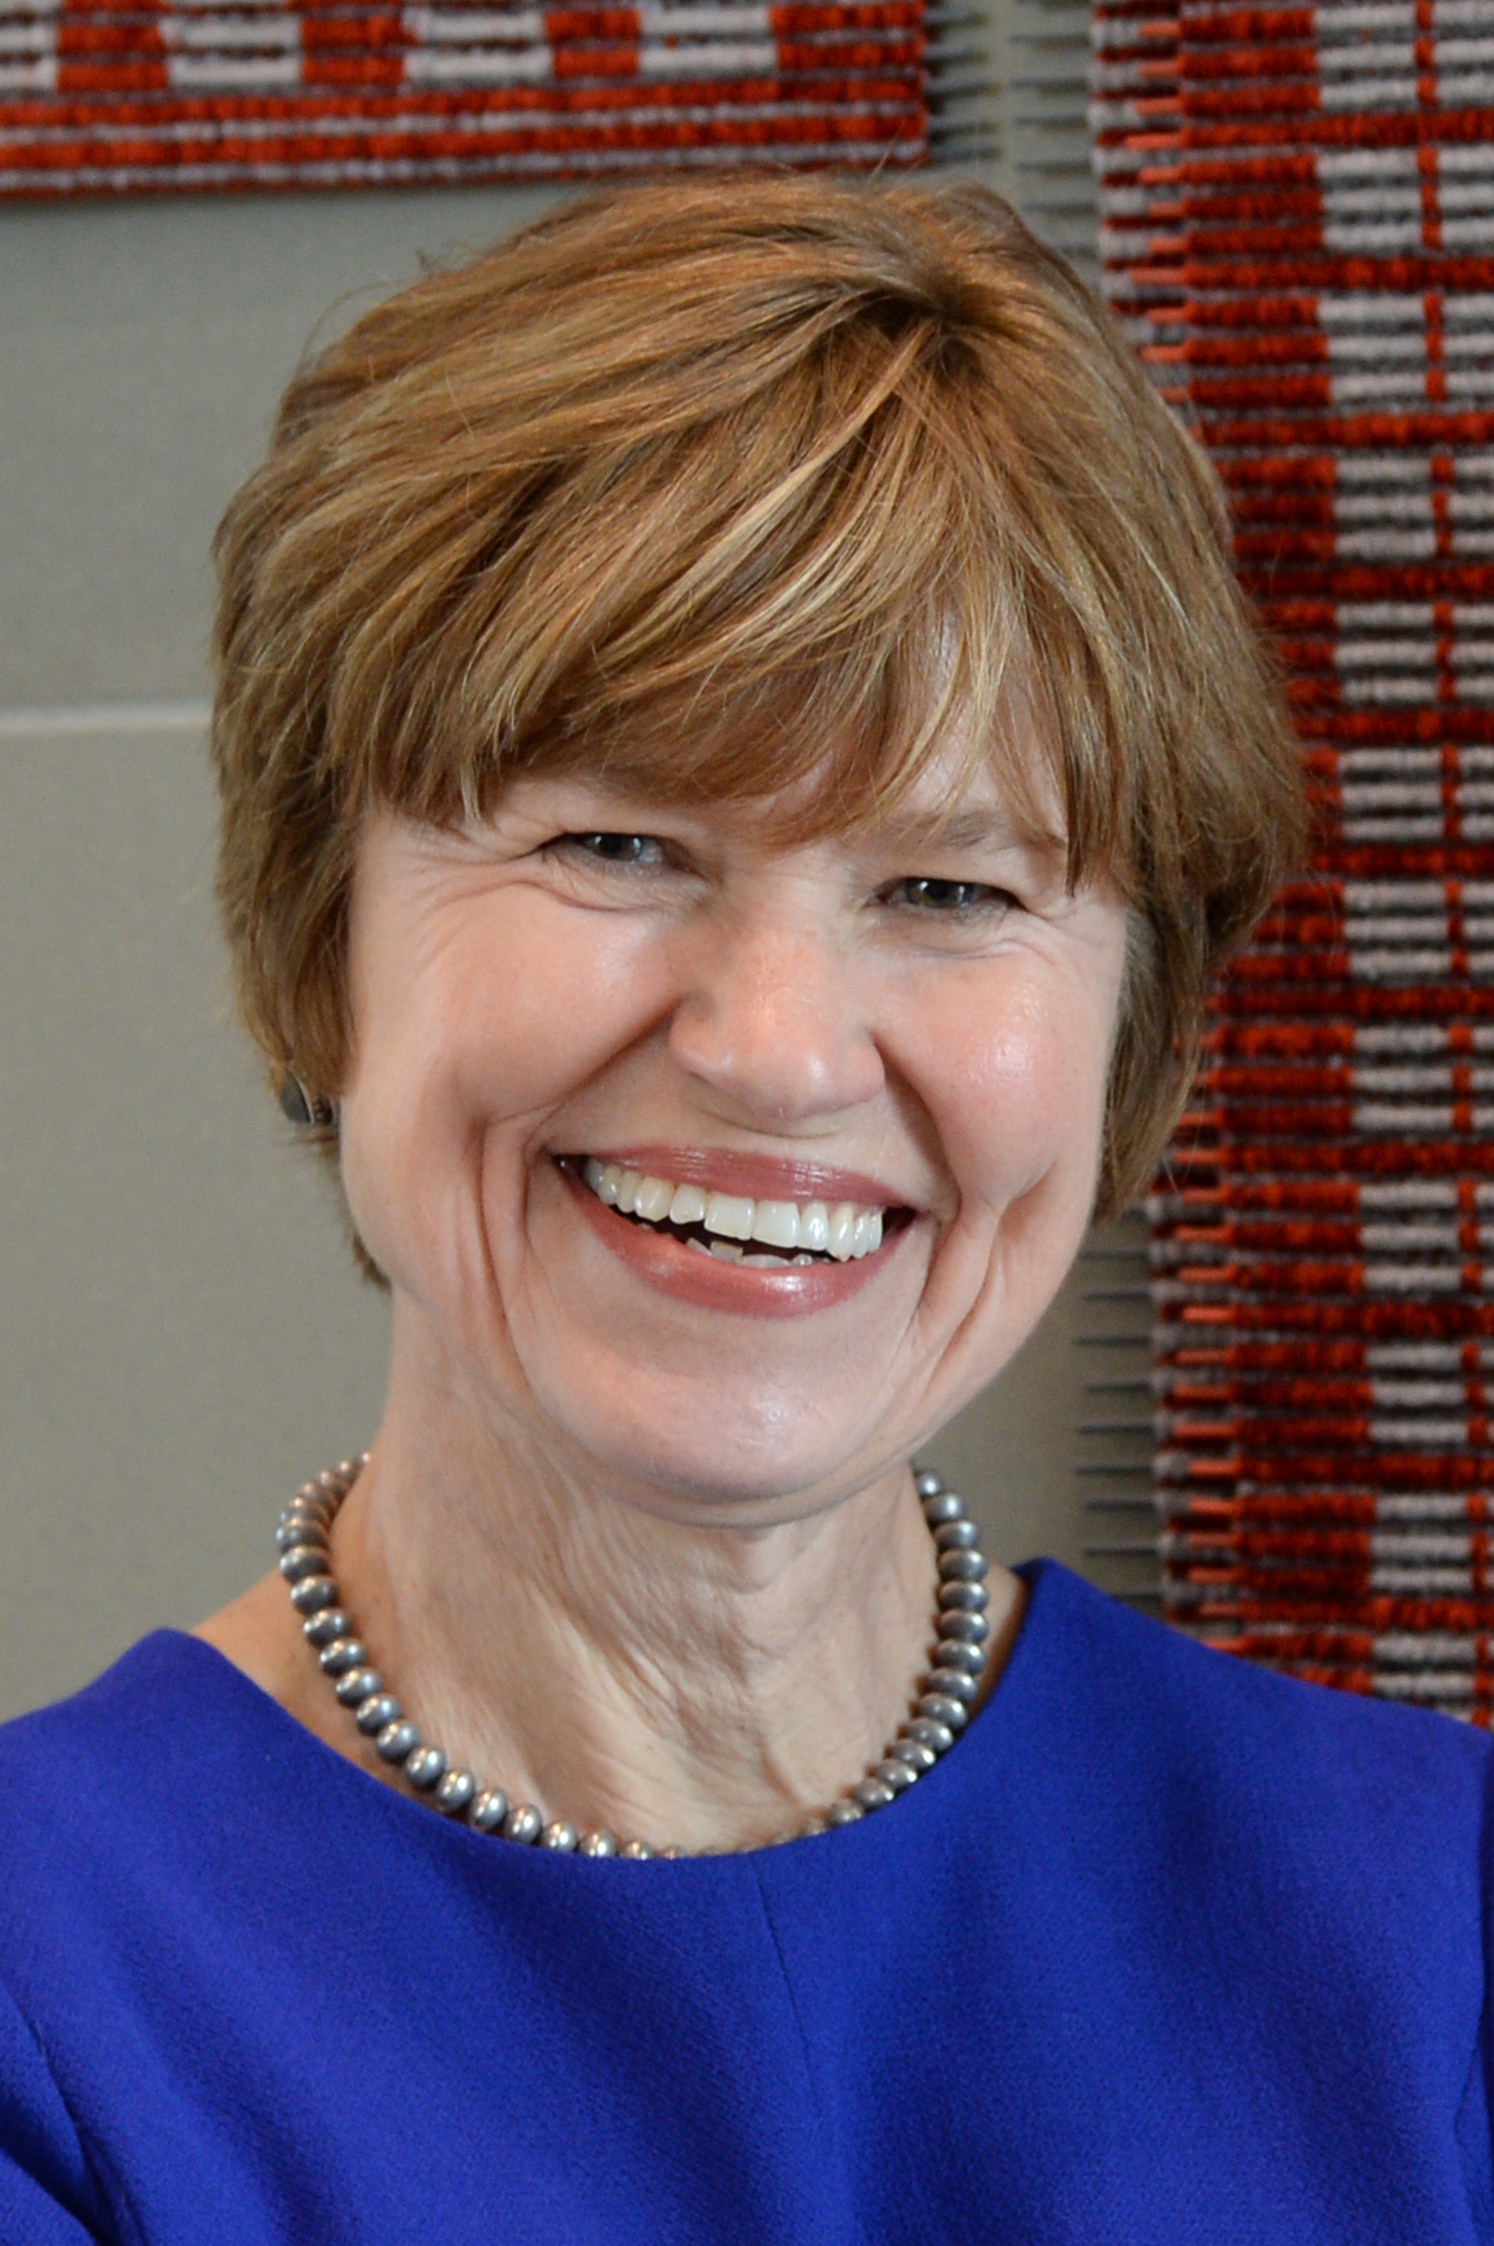

This month’s speaker will be Representative Christine Chandler. Representative Chandler is a long-time resident of Los Alamos County who is serving in the New Mexico House of Representatives, District 43 (Los Alamos, Rio Arriba, Sandoval and Santa Fe). Her legislative committee assignments include House Taxation & Revenue and Judiciary.

Prior to her election to the New Mexico House, Rep. Chandler had been a two term Los Alamos County Councilor and has worked on numerous local civic boards and commissions. Before her retirement, she was a Los Alamos National Laboratory lawyer and group leader, having managed the Litigation Group in Office of Laboratory Counsel. Rep. Chandler has law degrees from Boston College and Georgetown University Law Schools.

Representative Chandler will give an overview of the 2022 legislative sessions. She will highlight the major pieces of legislation that prevailed in both chambers as well as some that didn’t. Rep. Chandler will offer personal observations about working with the current administration as well as House/Senate dynamics.

MEETING DETAILS

This month’s meeting will be on Tuesday April 19th. Because of the ongoing COVID situation, the meeting will again be a Zoom session. It will start at 7:00 pm. Zoom details will be in the reminder email.

LAST MONTH: SPEAKER

Last month, LAPD Detective Michael Weiss presented Frauds and Scams. These crimes are prevalent in Los Alamos County. Fraud is defined in the state code as taking money by fraudulent means. The code defines three categories of fraud. If the amount is less than $250, it is a petty misdemeanor. If the amount is at least $250 and not more than $20,000, it is a 3rd degree felony. More than $20,000 makes it a 2nd degree felony.

He then listed a number of popular frauds that one might encounter. The most common fraud is a call supposedly from the Social Security Administration. The never call you; they always make contact by mail. So never give your Social Security number out over the telephone.

Another common fraud is a call from a loved one supposedly as a hostage or in a foreign jail. However, he is not aware of these calls happening in New Mexico. Other similar telephone frauds include outstanding arrest warrants, fraudulent technical support, and winning sweepstakes but taxes on the winning must be paid. Online frauds include invoices for items that you did not order. Usually, the caller request payment via purchasing gift cards. The government never asks for gift cards.

If you get one of these calls, ask questions. Request their telephone number and say you will call them back. Don’t share any personal information or account numbers. If it sounds too good to be true, it isn’t true. Use security tools on your computers, telephones, and other electronic devices.

If you become a victim, contact your bank and credit card companies and freeze your accounts. Lock all accounts and request a free credit check. Report the fraud to the police. Take good notes and save all numbers, emails, names, etc. Stop interacting with the scammers.

What can law enforcement do? They can issue search warrants, conduct interviews, and do other investigating. They may be able to track the call back to its origin. They also work with the FBI and other federal agencies and have international contacts. He mentioned one case that they are working with the Singapore police. They also work with banks and other financial institutions to try to keep the fraud from happening by questioning frequent or large withdrawals.

Where can you report a fraud or scam attempt. Consumer.ftc.gov has articles on frauds and a place to report frauds and identity theft. IC3, the Internet Crime Complaint Center is an FBI center that covers frauds. Econsumer.gov is another place to file complaints. USA.gov has reports on scams and frauds. Of course, report any frauds to your local police department.

Using VOIP for calls makes it easy to present fake telephone numbers to your caller identification.

In the questions session, Robert Hull presented an instance where he checked into a hotel and paid for his room and the rooms of other family members in the party. When he got to his room, he received a call saying it was the desk and they had problems with his credit card. They requested he repeat his credit card number over the telephone so that they could rerun it. He realized it was a problem and did not give out hi number. Other members of his party got similar calls, but since they didn’t pay for the rooms, they did not have the card number. Apparently when checking in, a scammer overheard the room numbers and tried to get the credit card information to misuse it.

LAHS NJROTC news

Throughout this month, many events have taken place. To start off, staff members C/LTJG Stephanie Peters, and C/LCDR Aleena Fullop organized the unit AMI. This years’ AMI was a success. It ran smoothly, and we are very proud of how Topper Company did. During the beginning of March, myself along with C/CPO Marissa Meierdierks organized a food drive for the school. It was also used as an opportunity for cadets to gain hours if they bring in items. At the end, we collected exactly 880 items to donate, another great success among the unit. Lastly, thinking ahead into April, we’ve planned the Topper Company’s Military Ball.

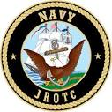
C/ENS Megan Crawford

FOR THE GOOD OF THE CHAPTER

Strategic Planning Update

1. I recommend that the following revised 2022-2026 National Strategic Goals (with rationale) be adopted:

A. Strategic Goal 1 (SG-1). Recruit, Convene & Involve Companions. (Leave as is … No recommended changes)
B. Strategic Goal 2 (SG-2). Provide Companion Leadership Training.
B. Strategic Goal 2 (SG-2). Mentor and Develop Companions through Enhanced Leadership Training. (Combines two related Strategic Goals into one).
C. Strategic Goal 3 (SG-3). Conduct Chapter Advertising and Publicity Increase National and Chapter Visibility through Comprehensive National and Local Marketing Strategies. (To date the Order has placed advertising and publicity on the backs of Chapters with no National strategy: this verbiage changes that and expands the requirement to more than just advertising and publicity but centers around a cohesive and effect marketing approach).
D. Strategic Goal 4 (SG-4). Modernize the Order Utilizing Current Technological Capabilities (An effort that is required at the National, Region, and Chapter levels if the Order is to survive).
E. Strategic Goal 5 (SG-5). Strengthen and Expand & Improve Chapter Outreach Programs. (“Strengthening” Chapter Programs is a more measurable term than just improving a program, and also emphasizes the importance of what Chapters should strive for rather than just having “fill the square” programs: this is absolutely essential to positive Chapter recruitment).
F. Strategic Goal 6 (SG-6). Recognize Companion, [Chapter, and Community Excellence. (Expands the goal to include recognizing not only Companions but also excellence at the Chapter and Community Levels, something that all Chapters need to do).

2. This proposal is provided at your request: please contact me if you have any questions or concerns.

Respectfully Submitted
Dave Worley

ED note: red is new, italics is delete

Dear Companions,

HQ MOWW is initiating a membership satisfaction survey. We are requesting that all Companions participate by taking this short survey (estimated 6 Minutes) to provide feedback to your National Headquarters. It is crucial that we obtain candid, professional feedback from as many Companions as possible to assist us in improving our programs and our Order.
MOWW Companions will be receiving direct e-mail notification with the survey link on 25 March 2022. The Survey link will also be posted to moww.org.
If Companions do not receive the Survey Monkey e-mail, they can access the MOWW Membership Satisfaction Survey at the following link: https://www.surveymonkey.com/r/M2XV7G2
Thank for your dedication to improving our Order.

FOR THE GOOD OF THE ORDER
Sincerely,
Michael Farrell Colonel, USMC (Retired) Chief of Staff & COO, MOWW, Inc.®

As you know, the 2022 Convention will be in Jacksonville, FL; the 2023 Convention will be in Annapolis MD. Another East Coast Region has expressed interest in hosting the 2024 Convention. The National leadership has expressed concern about three back-to-back-to back Conventions all on the East Coast. There has been some discussion lately within our own Region by Companions in the Southern AZ area who are interested in hosting a convention in 2024 perhaps wrapping it into a Region-wide event.

NATIONAL OFFICERS

- COMMANDER IN CHIEF
LTC Michael A. Okin M.D. USA (Ret)
maokin1953@gmail.com

- VICE COMMANDEER IN CHIEF
Lt Col Marlon Ruiz, USAF (Ret)
ruizmarlon08@gmail.com

- REGION XIII COMMANDER
LTC Patrick C. Stolze, USA (Ret)
pstolze40@gmail.com

website www.MOWWSCV.com

NATIONAL STAFF

- CHIEF OF STAFF & COO
Col Michael Farrell, USMC (Ret) | chiefofstaff@moww.org

- DIRECT OF FINANCE
Mrs. Martha Ferrara, CPA | finance@moww.org

- MANAGER, MEMBERSHIP PROGRAMS (including dues payments)
HPM Justin Hiller | membership@moww.org

- MANAGER, MOWW STORE
Mrs. Sunny Alley | merchandise@moww.org

Website www.moww.org

MG MILES CHAPTER OFFICERS

Commander
LTC Gregg Giesler USA (Ret)
Home: 505-662-5574
g.giesler@computer.org

Senior Vice Commander
HPM Vernon V. Haywood, Jr.
Home: 505-661-4192
vvhaywoodjr@att.net

Adjutant
HPM Vernon V. Haywood, Jr.
Home: 505-661-4192
vvhaywoodjr@att.net

Treasurer
COL Gerald Bolme USAF (Ret)
Home: 505-672-1233
bolme@earthlink.net

Chaplain
MAJ Donald B. Davidson, Jr., USA (Ret)
Home: 505-672-3794
dbd1alamos@msn.com

COMING EVENTS

April
12 Staff Meeting -
19 Chapter Dinner – Christine Chandler - Legislative Session Review
8 NJROTC Awards Ceremony, Smith Auditorium -

May
9 Staff Meeting
17 Chapter Dinner – Alan Carr
30 Memorial Day Ceremony –

June
? SPYLC -
13 Staff Meeting
? Region XIII Conference
21 Chapter Dinner & Elections/Installation of Officers –
28 1994 Chapter chartered

